# Abstract

The internet of things (IoT) is connecting the devices and tools to the internet network to be controlled by websites and smart phone applications remotely, also, to control tools and instruments by codes and algorithms structures for artificial intelligence issues. In case we want to create advanced systems using assembly algorithms, Wi-Fi or Ethernet connection is connected to our tools, equipment, and devices controlling them by smart phone applications or internet websites. That’s actually the simplified definition of IoT. Farther than just using the IoT as acircuit braker to operate lamps or other home-use devices, it can be used as a security system or an industrial-use system, for example, to open or close the main building gate, to operate full automatic industrial machine, or even to control internet and communication ports. And more ideas can be done by using IoT technology. A huge industrial facilities or governmental institutions have much of lamps. Employees sometimes forget to turn them off in the end of the day. This research suggests a solution that can save energy by letting the security to control lighting of the building with his smart home by Blynk application. The lamps can be controlled by switches distributed in the building and Blynk application at the same time with a certain electrical installation. This research presents a simple prototype of smart home, or the easy way and low cost to control loads by Wi-Fi connection generally.

# INTRODUCTION

A load controlled by computer systems has many advantages compared with manual controlled loads. Nowadays there are many programs and applications help to control things better using codes or python algorithms in artificial intelligence projects. In order to save energy and make loads monitored easily, this research suggests smart home project based on IoT technology. This smart home is an Internet of Things (IoT) project that controls loads with internet connection via Wireless Fidelity WIFI connection. A smart phone connected to internet with Blynk application as a control panel, and NodeMCU microcontroller kit in other side as a controller that receives control commands via WIFI signal. NodeMCU kit is built with ESP8266 WIFI receiver that able to process and analyze WIFI signal to input the microcontroller. The WIFI receiver and microcontroller are built in one kit to be used as IoT project. It’s called NodeMCU.

To connect the system to the Internet, needs a WiFi receiver. In my case I used ESP8266 that is connected as built-in in the NodeMCU board that contains a firmware runs with the ESP8266. The firmware is a low-level control computer software.

The NodeMCU is coded via Arduino Integrated Development Environment (IDE) with the Universal Serial Bus port (USB) to tell the NodeMCU what to do, I want to make the NodeMCU controls four-channel relay kit by Blynk hand phone application and shows the temperature that measured by LM35 sensor.

Parts used to create the project:

1. NodeMCU board. Open source internet of things platform.
2. AC-DC step down converter. Switch mode power supply to provide the project with power. This project needs 5 volts.
3. DC-DC step down converter as a regulator to convert the 12 V output of the power supply into regulated 5 V.
4. Four-channel relay kit. To drive loads from digital NodeMCU output pins.
5. LM35 temperature sensor. To measure room temperature.
6. Computer with Arduino (IDE) program installed to code the NodeMCU once.
7. Android smart phone with Blynk application installed to be used as control panel.

# METHOD

This research is conducted based on the important steps that are done by orienting on the success indicators in connecting the NodeMCU ESP8266 module and other devices so that it can be used to solve multi-objective problems. To achieve these indicators, the stages of this research are as follows:

1. Analysis of the problem. Analyze the problems to be studied regarding smart home.
2. Analysis of needs. In this case all needs in researching both from journals, literature books, tools, and materials.
3. System design. Designing tools to be built using the NodeMCU ESP8266 module, and the sensors used.
4. System programming. Make a program using the Arduino IDE and the Blynk android application.
5. Testing tools. Testing tools with program codes created and internet connections.
6. Making reports and summarizing the results of the experiment. See system responsiveness to commands given to smart home.

# The Flow of The System

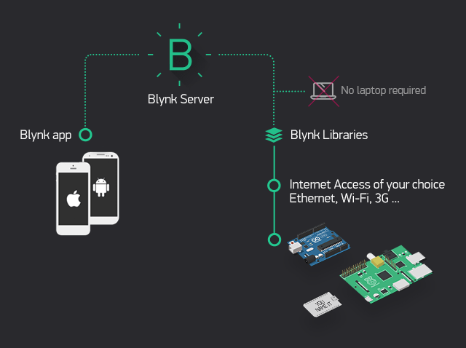

Figure 1. Blynk System Principle

The system is based on NodeMCU board as an internet of things system. The NodeMCU is connected to the internet from the hotspot of the smart phone via WIFI connection as the NodeMCU has ESP8266 circuit to connect with the internet.

NodeMCU to be connected to the hotspot of the smart phone, needs to be identified to the name of hotspot, the password and token code letting the server of Blynk connects them together. You may need the computer once to transfer code from Arduino IDE to the NodeMCU kit to prepare the software part of the project*.* Figure 1 shows that the server of Blynk application will process the smartphone-NodeMCU connection. Blynk libraries are ZIP files can be downloaded from Github website to be imported to the Arduino IDE library.

Blynk server will check for internet connection, NodeMCU with android hotspot, the NodeMCU code includes the token code, the name of hotspot and it’s password. The information included to the code must be match with the hotspot information to allow ESP8266 connect with the WIFI to be as a channel to exchange commands between smart phone and NodeMCU. Remaining processes are just commands sent from Blynk application to NodeMCU to control loads those are connected to the relay kit as shown in Figure 2. And sensor output value is sent reverse to the Blynk application from NodeMCU kit.

NodeMCU ESP8266 initialized



Start

Blynk application

check wheter there is internet connection?

Check for

smart phone internet connection

Y

Bulbs ON/OFF from blynk application

N

A

Relay control initialized

A

Bulbs ON/OFF

controlled by relay kit

End

\

Figure 2. Flowchart of Load ON/OFF

To show the temperature value in Celsius degrees on the android display, NodeMCU will send sensor output value in voltage to the Blynk application back. Like the ON/OFF process last flowchart, Blynk server will check for internet connection and hotspot name and password, the sensor output value to show the temperature correctly. The temperature is showed by gauge tool in the Blynk application after setting the input pin and temperature scale as shown in Figure 3***.***



Start

Blynk application check

wheter there is internet connection?

N Check for smart phone

internet connection

Y

Temperature sensor





Temperature value

on the screen

End

NodeMCU ESP8266 initialized

Figure 3. Flowchart of Temperature Sense

# The Block Diagram of the System

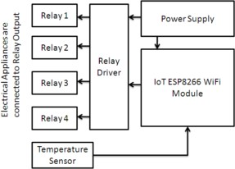

Figure 4. System Block Diagram

Figure 4 shows the system block diagram. The Power Supply will provide energy to the system through the relay and NodeMCU ESP8266 modules, so that all equipment can work and function properly. NodeMCU ESP8266 microcontroller will read the temperature by the Temperature sensor LM35, and then send the data to the Blynk server in TCP / IP format for display on the smart phone. NodeMCU ESP8266 microcontroller will also read commands that have been sent by the Blynk Server in TCP / IP format which will then be changed by giving the logic "HIGH" or "LOW" on certain pins by relay to regulate the on / off of the home lights. Cloud (internet) by utilizing Wi-Fi becomes the central connection between Blynk application and NodeMCU project.

# Blynk application and Arduino IDE Preparation and Running

This project is running by Blynk application. Down load the application to a smart phone from Google play store and then create a project on it with four switches and one gauge to be as a temperature scale. Set buttons to be switches on D1, D2, D3 and D4. Then set gauge on A0 because the sensor output is on A0 in NodeMCU board. Figure 5 shows screenshots from Blynk application

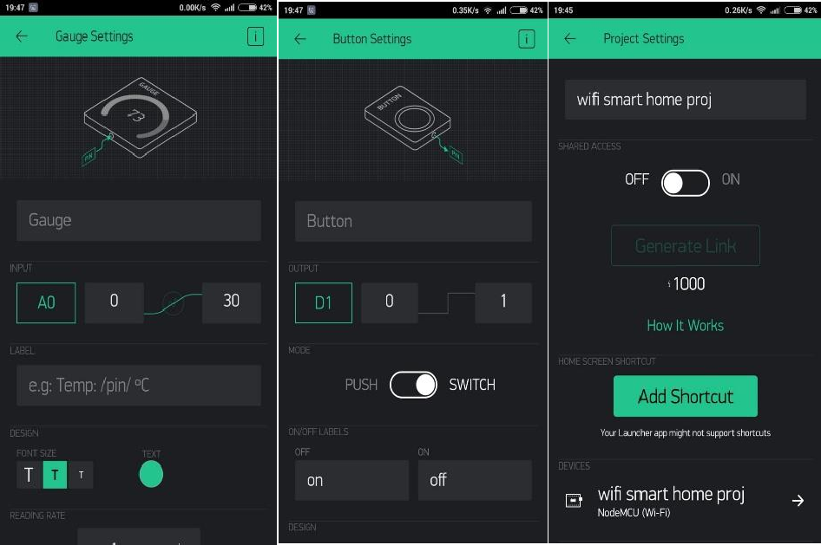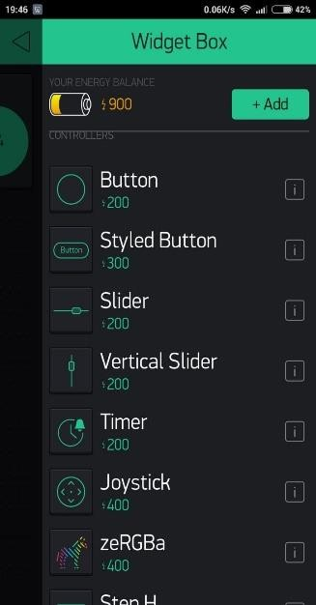

Figure 5. Screenshots from Blynk Application

# NodeMCU Code via Arduino IDE

To code NodeMCU via Arduino IDE, the NodeMCU needs to be added to Arduino IDE library first by adding this address to Arduino IDE preferences. After this reference is added to Arduino IDE, download nodeMCU to boards manager and then select NodeMCU 1.0 (ESP- 12E Module). After nodeMCU is added to Arduino IDE library, upload this code with changing hotspot name and password also token code. Shown in figure 6.

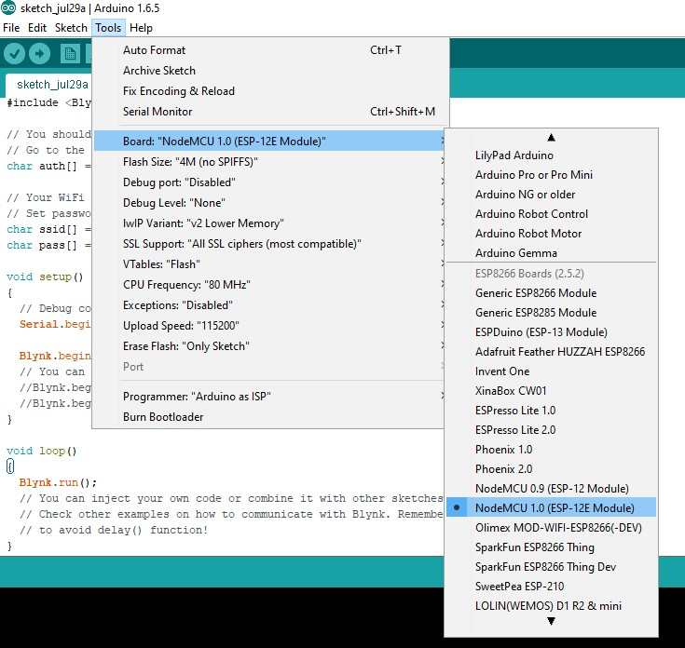

Figure 6. Setting up NodeMCU in Arduino IDE

Figure 7 shows the NodeMCU code. The code includes the hotspot name and password match with the android. The code does not need to identify the relay input, as it is included in

[Blynk.run();]. When auth (autho token) is given by Blynk application sent as email and SSID is the name of smart phone hotspot.

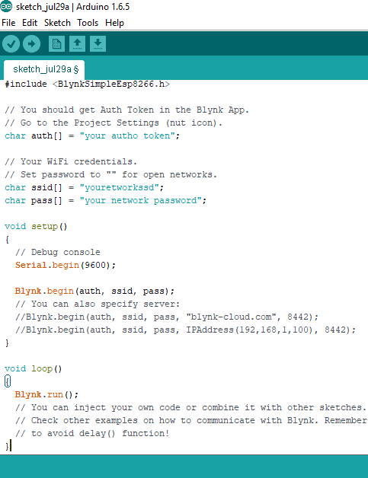

Figure 7. NodeMCU Code

# The Hardware of the System

As mentioned above, components used to build the circuit, NodeMCU needs 5VDC as a supply voltage Vin pin, AC-DC step down converter 12V and DC-DC step down converter 5V, in case using AC-DC step down converter 5V, no need to use DC-DC converter. Output voltage of the power supply is connected to Vin NodeMCU, Vcc of relay kit and VCC of LM35 temperature sensor. When the ground is common. D1,D2,D3 and D4 are outputs and A0 is an analog signal input is connected to the temperature sensor as shown in Figure 8. Using Fritzing software to draw and simulate the circuit as shown in Figure 9.

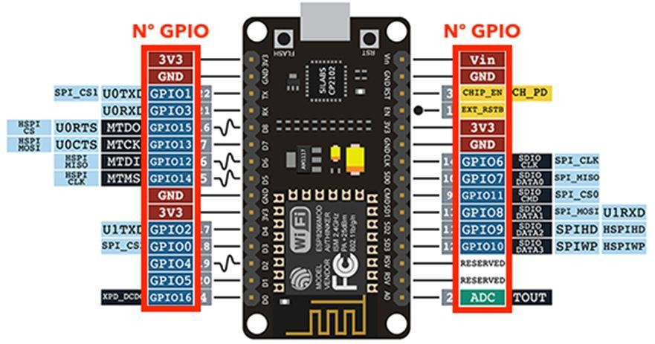

Figure 8. NodeMCU Pinout

Pins used:

* + 1. Vin is connected to power supply output 5VDC.
    2. GND is ground.
    3. D1,D2,D3 and D4 are used as digital outputs.
    4. A0 is used as analog signal input to input sensor signal.

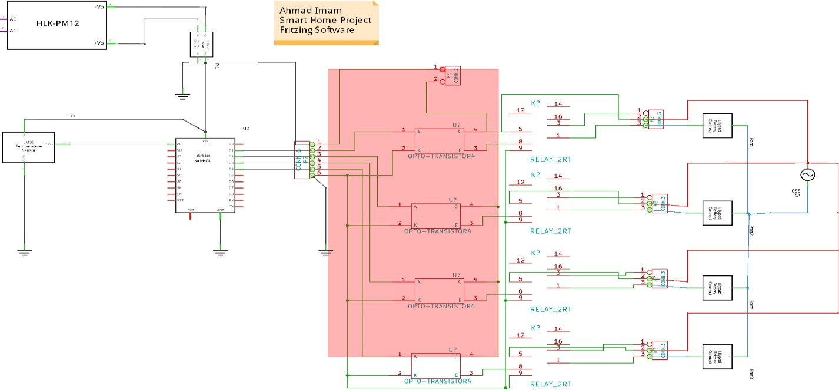

Figure 9. The Circuit Diagram

* + 1. Relay Module

As shown in figure 10, relay module is being connected directly to digital circuits including microcontroller kits easily to control big loads by a microcontroller. The inputs IN1, IN2, IN3 and IN4 operate four relays with voltage between 3-5 volts DC. Input and output circuits are separated by Optocouplers to protect digital circuits in case connection mistakes happened or short circuits.

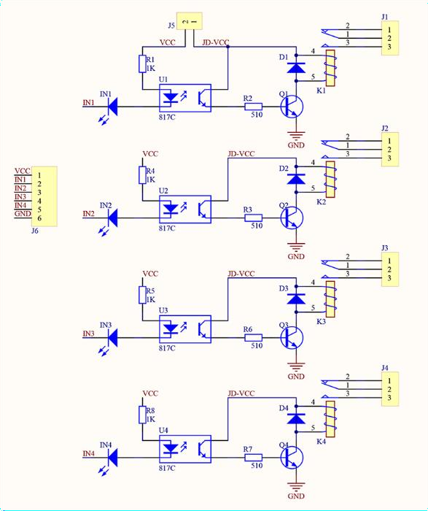

Figure 10. Relay Module Circuit Diagram

* + 1. LM35 Temperature Sensor

LM35 is an integrated circuit that works in range 4-20V DC as a temperature sensor with a precision at 10m V for one Celsius degree and low output impedance about 0.1 ohm at 1m A. LM35 is built in TO-92 package with three pins

1. Vcc
2. output
3. ground

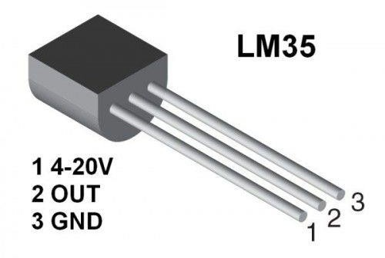

Figure 11. LM35 Pinout

# RESULTS AND DISCUSSION

* 1. **Light Control Test Results**

The Light Control Test is done by pressing the ON / OFF button widget on the Blynk application on the respective Android smart phone for lights and fans. This is done after the system is turned on and connected to a Wi-Fi internet connection. If at any time the internet connection is lost or bad signal, then it also affects system performance. Table 1 shows switches test results.

Table 1. Light Control Test

|  |  |  |
| --- | --- | --- |
| Switch status | On | Off |
|  | ---- | Relay 1  Relay 2  Relay 3  Relay 4 |
|  | Relay 1 | Relay 2  Relay 3  Relay 4 |
|  | Relay 2 | Relay 1  Relay 3  Relay 4 |
|  | Relay 3 | Relay 1  Relay 2 |

|  |  |  |
| --- | --- | --- |
|  |  | Relay 4 |
|  | Relay 4 | Relay 1  Relay 2  Relay 3 |
|  | Relay 1  Relay 2  Relay 3  Relay 4 | ---- |

# LM35 Sensor Test

LM35 Sensor Testing is done by recording the temperature changes that occur every minute. This is done after the system is turned on and connected to a Wi-Fi internet connection. If at any time the internet connection is disconnected or bad signal, then it also affects system performance.

Table 2. Temperature Test

|  |  |
| --- | --- |
| Minute | Temperature |
| 1 | 32 |
| 2 | 33 |
| 3 | 33 |
| 4 | 34 |
| 5 | 33 |
| 6 | 32 |
| 7 | 33 |
| 8 | 34 |
| 9 | 33 |
| 10 | 33 |

# System Analysis

From testing the entire system above, the smart home works according to what is the purpose of this research. Comparison of this research with previous studies, namely this study uses temperature sensor and control buttons, thus increasing the diversity of the smart home system itself. Also, used a microcontroller that is different from previous studies that is the NodeMCU ESP8266 module which has advantages compared to other microcontrollers. The smart home has been successfully built with hardware arranged in such a way that it can achieve results that are as expected. In this case the hardware that plays a very important role as the main device is the NodeMCU ESP8266 module. The advantages of using the NodeMCU ESP8266 are more practical than buying various components and then assembling them by yourself.

# The Final Hardware Circuit Connection

Using components and materials mentioned above. Figure 12 shows the project that’s used as an (IoT) system controlled by Blynk application is running. Loads used in this project are bulbs, they can be changed with other devices by changing bulbs with AC plugs to connect home-use devices or equipment.

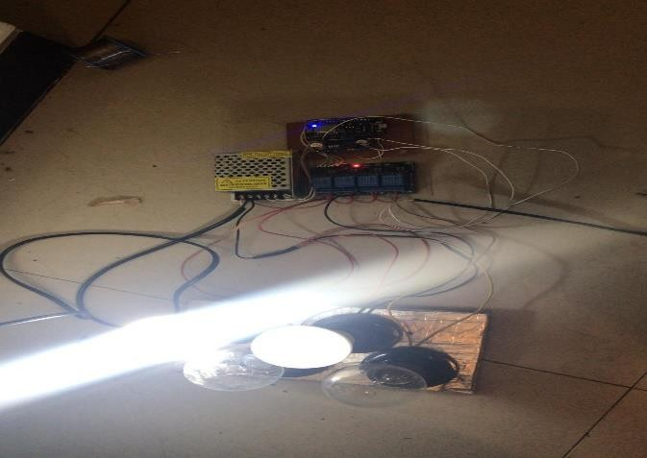

Figure 12. Project Test

**CIRCUIT DESCRIPTION**

**Microcontroller Section**

The connections and functions of the microcontroller are described below:

**4.2.2 MOSFET Section**

The frequency controlled switching is handled by MOSFET section in which the output frequency signal from the microcontroller is current amplified using a network of a buffer in parallel with a variable resistor ~ 10K & a capacitor of 104 pf additionally a protective circuit consisting of 1N4007 diode in parallel with a resistance of 330 K is attached with the buffer to prevent the leakage current from the buffer.

The current amplified signal at 50 Hz frequency applied at the gate terminal is then utilized to switch the battery voltage at the drain terminal of the power MOSFET’s source of which is connected to the primary of the center tapped step up transformer. For a load utilizing 220V AC from a 100 VA inverter the current drawn at the output is about 450 mA and the current drawn by the primary of the transformer for 12V DC supply is about 8.3 Ampere. Switching converts DC to AC but the output is a SQUARE WAVE which is transformed into SINE WAVE by the step up transformer with ripples at the peak which causes the humming sound in AC devices.

**4.2.3 Supply Section**

The Circuit Architecture for supply consists of a step down transformer which converts the input supply voltage 200-240 V AC to 12-20 V AC which is then cascaded with a structure of 1N4007 diodes forming a bridge rectifier which converts the step down AC voltage to unregulated DC supply.

**Np.Vp=Ns.Vs**

**Equation 11 : Transformer Equation**

The transformer equation clearly suggest that if the input supply is less the output voltage will also lessen up. Ripples in the unregulated DC voltage is removed using a capacitor filter of 1000 mfd which is then supplied to LM 7805 regulator to obtain a regulated 5V DC. After filters 100 mfd & 104 pf are also used for obtain pure DC output of 5V which is utilize as Vcc for Microcontroller, LCD display, LED’s, Buzzer, Switch etc. The transformer secondary voltage Vs after capacitive filter can be derived by the equation

**Vo=Vs√2**

**Equation 12: Secondary Transformer voltage after capacitive filtering**

The output for a input supply of 200 V AC after capacitive filtration comes out to be nearly equal to 16V DC which is fed to regulator LM 317 a variable response regulator which gives a output of 15V DC to charge the battery across diode D7 (1N4007) .

In case of battery is utilized i.e. when mains is off and inverter is working the battery gets discharged through diode D7 & D9 (1N4007) to the regulator LM 7805 which again provides 5V DC. A preventive diode D8(1N4007) is utilized for supply not falling back to mains. The supply section also includes a sensor which senses supply from mains and act as a switch for the microcontroller. This sensor is a PNP transistor whose base goes high making PNP off and the CE is open circuit which is connected to P 1.0 of the microcontroller hence it goes LOW. When MAINS is off the base goes LOW making CE short circuited & P 1.0 goes high.

* + 1. **Display & Alarm Section**

The output on the LCD is in accordance with the programming and changes accordingly with main supply & inverter i.e. battery supply and battery going below 10V which is like

1)Main Supply:

**WELCOME MAINS ON**

**CHARGING**

2)Inverter i.e. On Battery:

**INVERTER ON**

**FREQUENCY 50 Hz**

3)Battery below 10V

**BATTERY LOW**

A potential divider circuit with resistances 6.2K and 1K is attached with battery and P1.1 and P1.2 pins of the microcontroller. If the battery goes below 9 ~ 10V pin P1.2 senses the change and generate an interrupt which is at highest priority and is satisfied by P3.5 pin going low and at this condition the Buzzer beeps.

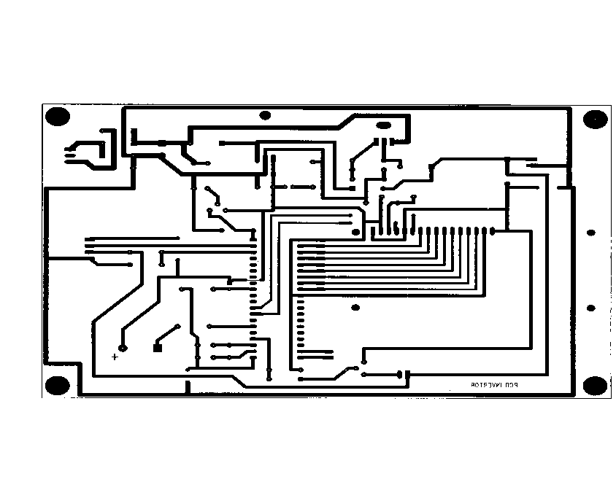

**Printed Circuit Boards**

**Printed Circuit Boards**

In [electronics](http://en.wikipedia.org/wiki/Electronics), printed circuit boards, or PCBs, are used to mechanically support and electrically connect [electronic components](http://en.wikipedia.org/wiki/Electronic_component) using [conductive](http://en.wikipedia.org/wiki/Conductor_%28material%29) pathways, or [traces](http://en.wikipedia.org/wiki/Signal_trace), [etched](http://en.wikipedia.org/wiki/Industrial_etching) from copper sheets [laminated](http://en.wikipedia.org/wiki/Laminated) onto a non-conductive substrate. Alternative names are printed wiring board (PWB),and etched wiring board. Populating the board with electronic components forms a printed circuit assembly (PCA), also known as a printed circuit board assembly ([PCBA](http://en.wikipedia.org/wiki/Printed_Circuit_Board_Assembly)). PCBs are rugged, inexpensive, and can be highly reliable. They require much more layout effort and higher initial cost than either [wire-wrapped](http://en.wikipedia.org/wiki/Wire_wrap) or [point-to-point constructed](http://en.wikipedia.org/wiki/Point-to-point_construction) circuits, but are much cheaper, faster, and consistent in high volume production.

Printed circuit boards fall into the following categories:

**Motherboard** : The principal board that has connectors for attaching [devices](http://www.webopedia.com/TERM/P/device.html) to the [bus](http://www.webopedia.com/TERM/P/bus.html). Typically, the mother board contains the [CPU](http://www.webopedia.com/TERM/P/CPU.html), [memory](http://www.webopedia.com/TERM/P/memory.html), and basic [controllers](http://www.webopedia.com/TERM/P/controller.html) for the [system](http://www.webopedia.com/TERM/P/system.html). On [PCs](http://www.webopedia.com/TERM/P/PC.html), the motherboard is often called the system board or mainboard.

[**Expansion board**](http://www.webopedia.com/TERM/P/expansion_board.html) : Any board that plugs into one of the computer's [expansion slots](http://www.webopedia.com/TERM/P/expansion_slot.html). Expansion boards include controller boards, [LAN](http://www.webopedia.com/TERM/P/local_area_network_LAN.html) cards, and [video adapters](http://www.webopedia.com/TERM/P/video_adapter.html).

[**Daughter card**](http://www.webopedia.com/TERM/P/daughtercard.html) : Any board that attaches directly to another board.

**Controller board**: A special type of expansion board that contains a controller for a [peripheral device](http://www.webopedia.com/TERM/P/peripheral_device.html). When you attach new devices, such as a [disk drive](http://www.webopedia.com/TERM/P/disk_drive.html) or graphics monitor, to a computer, you often need to add a controller board.

[**Network Interface Card (NIC)**](http://www.webopedia.com/TERM/P/network_interface_card_NIC.html) : An expansion board that enables a PC to be connected to a local-area network (LAN).

**Video adapter**: An expansion board that contains a controller for a [graphics monitor](http://www.webopedia.com/TERM/P/graphics_monitor.html).

Printed circuit boards are also called cards.

* + 1. **Manufacturing**

**Patterning (etching)**

The vast majority of printed circuit boards are made by adhering a layer of copper over the entire substrate, sometimes on both sides, (creating a "blank PCB") then removing unwanted copper after applying a temporary mask (eg. by etching), leaving only the desired copper traces. A few PCBs are made by adding traces to the bare substrate (or a substrate with a very thin layer of copper) usually by a complex process of multiple [electroplating](http://en.wikipedia.org/wiki/Electroplating) steps.

There are three common "subtractive" methods (methods that remove copper) used for the production of printed circuit boards:

1. [**Silk screen printing**](http://en.wikipedia.org/wiki/Silk_screen) uses etch-resistant inks to protect the copper foil. Subsequent etching removes the unwanted copper. Alternatively, the ink may be conductive, printed on a blank (non-conductive) board. The latter technique is also used in the manufacture of [hybrid circuits](http://en.wikipedia.org/wiki/Hybrid_circuit).
2. [**Photoengraving**](http://en.wikipedia.org/wiki/Photoengraving) uses a photomask and chemical etching to remove the copper foil from the substrate. The photomask is usually prepared with a [photoplotter](http://en.wikipedia.org/wiki/Photoplotter) from data produced by a technician using CAM, or [computer-aided manufacturing](http://en.wikipedia.org/wiki/Computer-aided_manufacturing) software. Laser-printed transparencies are typically employed for phototools; however, direct laser imaging techniques are being employed to replace phototools for high-resolution requirements.
3. [**PCB milling**](http://en.wikipedia.org/w/index.php?title=PCB_milling&action=edit) uses a two or three-axis mechanical milling system to mill away the copper foil from the substrate. A PCB milling machine (referred to as a 'PCB Prototyper') operates in a similar way to a [plotter](http://en.wikipedia.org/wiki/Plotter), receiving commands from the host software that control the position of the milling head in the x, y, and (if relevant) z axis. Data to drive the Prototyper is extracted from files generated in PCB design software and stored in [HPGL](http://en.wikipedia.org/wiki/HPGL) or [Gerber](http://en.wikipedia.org/wiki/Gerber_File) file format.

"Additive" processes also exist. The most common is the "semi-additive process. In this version, the unpatterned board has a thin layer of copper already on it. A reverse mask is then applied. (Unlike a subtractive process mask, this mask exposes those parts of the substrate that will eventually become the traces.) Additional copper is then plated onto the board in the unmasked areas; copper may be plated to any desired weight. Tin-lead or other surface platings are then applied. The mask is stripped away and a brief etching step removes the now-exposed original copper laminate from the board, isolating the individual traces.The additive process is commonly used for multi-layer boards as it facilitates the plating-through of the holes (vias) in the circuit board.

**Lamination**

Some PCBs have trace layers inside the PCB and are called multi-layer PCBs. These are formed by bonding together separately etched thin boards.

**Drilling**

Holes, or vias, through a PCB are typically drilled with tiny drill bits made of solid [tungsten carbide](http://en.wikipedia.org/wiki/Tungsten_carbide). The drilling is performed by automated drilling machines with placement controlled by a drill tape or drill file. These computer-generated files are also called numerically controlled drill (NCD) files or "[Excellon files](http://en.wikipedia.org/wiki/Excellon_file)". The drill file describes the location and size of each drilled hole. When very small vias are required, drilling with mechanical bits is costly because of high rates of wear and breakage. In this case, the vias may be evaporated by [lasers](http://en.wikipedia.org/wiki/Laser). Laser-drilled vias typically have an inferior surface finish inside the hole. These holes are called micro vias. It is also possible with controlled-depth drilling, laser drilling, or by pre-drilling the individual sheets of the PCB before lamination, to produce holes that connect only some of the copper layers, rather than passing through the entire board. These holes are called blind vias when they connect an internal copper layer to an outer layer, or buried vias when they connect two or more internal copper layers.

The walls of the holes, for boards with 2 or more layers, are plated with copper to form plated-through holes that electrically connect the conducting layers of the PCB. For multilayer boards, those with 4 layers or more, drilling typically produces a smear comprised of the bonding agent in the laminate system. Before the holes can be plated through, this smear must be removed by a chemical de-smear process, or by plasma-etch.

**Exposed conductor plating and coating**

The pads and lands to which components will be mounted are typically plated, because bare copper oxidizes quickly, and therefore is not readily solderable. Traditionally, any exposed copper was plated with [solder](http://en.wikipedia.org/wiki/Solder). This solder was a [tin](http://en.wikipedia.org/wiki/Tin)-[lead](http://en.wikipedia.org/wiki/Lead) alloy, however new solder compounds are now used to achieve compliance with the [RoHS](http://en.wikipedia.org/wiki/RoHS) directive in the [EU](http://en.wikipedia.org/wiki/EU), which restricts the use of lead. Other platings used are OSP (organic surface protectant), immersion silver, electroless nickel with immersion gold coating (ENIG), and direct gold. [Edge connectors](http://en.wikipedia.org/wiki/Edge_connector), placed along one edge of some boards, are often [gold plated](http://en.wikipedia.org/wiki/Gold_plated).

**Solder resist**

Areas that should not be soldered to may be covered with a polymer solder resist (solder mask) coating. The solder resist prevents solder from bridging between conductors and thereby creating short circuits. Solder resist also provides some protection from the environment.

**Screen printing**

Line art and text may be printed onto the outer surfaces of a PCB by [screen printing](http://en.wikipedia.org/wiki/Screen-printing). When space permits, the screen print text can indicate component designators, switch setting requirements, test points, and other features helpful in assembling, testing, and servicing the circuit board.Screen print is also known as the silk screen, or, in one sided PCBs, the red print.

**Test**

Unpopulated boards may be subjected to a bare-board test where each circuit connection (as defined in a netlist) is verified as correct on the finished board. For high-volume production, a [Bed of nails tester](http://en.wikipedia.org/wiki/Bed_of_nails_tester) or fixture is used to make contact with copper lands or holes on one or both sides of the board to facilitate testing. A computer will instruct the electrical test unit to send a small amount of current through each contact point on the bed-of-nails as required, and verify that such current can be seen on the other appropriate contact points. For small- or medium-volume boards, flying-probe testers use moving test heads to make contact with the copper lands or holes to verify the electrical connectivity of the board under test.

**Populating**

After the PCB is completed, electronic components must be attached to form a functional printed circuit assembly, or PCA. In through-hole construction, component leads may be inserted in holes and electrically and mechanically fixed to the board with a molten metal solder, while in [surface-mount](http://en.wikipedia.org/wiki/Surface-mount) construction, the components are simply soldered to pads or lands on the outer surfaces of the PCB.Often, through-hole and surface-mount construction must be combined in a single PCA because some required components are available only in surface-mount packages, while others are available only in through-hole packages.

Again, [JEDEC](http://en.wikipedia.org/wiki/JEDEC) guidelines for PCB component placement, soldering, and inspection are commonly used to maintain [quality control](http://en.wikipedia.org/wiki/Quality_control) in this stage of PCB manufacturing. After the board is populated, the populated board may be tested with an [in-circuit test](http://en.wikipedia.org/wiki/In_circuit_test) system. To facilitate this test, PCBs may be designed with extra pads to make temporary connections. Sometimes these pads must be isolated with resistors. The in-circuit test may also exercise [boundary scan](http://en.wikipedia.org/wiki/Boundary_scan) test features of some components. In-circuit test systems may also be used to program nonvolatile memory components on the board. In boundary scan testing, test circuits integrated into various ICs on the board form temporary connections between the pcb traces to test that the ICs are mounted correctly. Boundary scan testing requires that all the ICs to be tested use a standard test configuration procedure, the most common one being the Joint Test Action Group ([JTAG](http://en.wikipedia.org/wiki/JTAG)) standard.

**Protection and packaging**

PCBs intended for extreme environments often have a conformal coat, which is applied by dipping or spraying after the components have been soldered. The coat prevents corrosion and leakage currents or shorting due to condensation. The earliest conformal coats were [wax](http://en.wikipedia.org/wiki/Wax). Modern conformal coats are usually dips of dilute solutions of silicone rubber, polyurethane, acrylic, or epoxy. Some are engineering plastics sputtered onto the PCB in a vacuum chamber. Many assembled PCBs are [static](http://en.wikipedia.org/wiki/Electrostatic_discharge) sensitive, and therefore must be placed in [antistatic bags](http://en.wikipedia.org/wiki/Antistatic_bag) during transport. When handling these boards, the user must be [earthed](http://en.wikipedia.org/wiki/Ground_%28electricity%29); failure to do this might transmit an accumulated static charge through the board, damaging or destroying it. Even bare boards are sometimes static sensitive. Traces have gotten so fine that it's quite possible to blow an etch off the board (or change its characteristics) with a static charge. This is especially true on non-traditional PCBs such as [MCMs](http://en.wikipedia.org/wiki/Multi-Chip_Module) and [microwave](http://en.wikipedia.org/wiki/Microwave) PCBs.

**2.7.2 Steps involved in making PCB**

* Prepare the layout of the circuit (positive).
* Cut the photofilm (slightly bigger) of the size of the layout.
* Place the layout in the photoprinter machine with the photofilm above it. Make sure that the bromide (dark) side of the film is in contact with the layout.
* Switch on the machine by pressing the push button for 5 sec.
* Dip the film in the solution prepared (developer) by mixing the chemicals A & B in equal quantities in water.
* Now clean the film by placing it in the tray containing water for 1 min.
* After this, dip the film in the fixer solution for 1 min. now the negative of the circuit is ready.
* Now wash it under the flowing water.
* Dry the negative in the photocure machine.
* Take the PCB board of the size of the layout and clean it with steel wool to make the surface smooth.
* Now dip the PCB in the liquid photoresist, with the help of dip coat machine.
* Now clip the PCB next to the negative in the photo cure machine, drying for approximate 10-12 minute.
* Now place the negative on the top of the PCB in the UV machine, set the timer for about 2.5 minute and switch on the UV light at the top.
* Take the LPR developer in a container and rigorously move the PCB in it.
* After this, wash it with water very gently.
* Then apply LPR dye on it with the help of a dropper so that it is completely covered by it.
* Now clamp the PCB in the etching machine that contains ferric chloride solution for about 10 minutes.
* After etching, wash the PCB with water, wipe it a dry cloth softly.
* Finally rub the PCB with a steel wool, and the PCB is ready.

**MICROCONTROLLER UNIT**

# MICROCONTROLLER AT89C51/89s52

# Features

• Compatible with MCS-51™ Products

• 8K Bytes of In-System Re programmable Flash Memory

• Endurance: 1,000 Write/Erase Cycles

• Fully Static Operation: 0 Hz to 24 MHz

• Three-level Program Memory Lock

• 256 x 8-bit Internal RAM

• 32 Programmable I/O Lines

•Three 16-bit Timer/Counters

• Eight Interrupt Sources

• Programmable Serial Channel

• Low-power Idle and Power-down Modes

### DESCRIPTION

The AT89C52 is a low-power, high-performance CMOS 8-bit microcomputer 8Kbytes of Flash programmable and erasable read only memory (PEROM). The device is manufactured using Atmel ’s high-density nonvolatile memory technology and is compatible with the industry standard 80C51 and 80C52 instruction set and pin out.

The on-chip Flash allows the program memory to be reprogrammed in-system or by a Conventional nonvolatile memory programmer. By combining a versatile 8-bit CPU with Flash on a monolithic chip, the Atmel AT89C52 is a powerful microcomputer that provides a highly flexible and cost-effective solution to many embedded control application.

The Power-down mode saves the RAM contents but Freezes the oscillator, disabling all other chip functions until the next hardware reset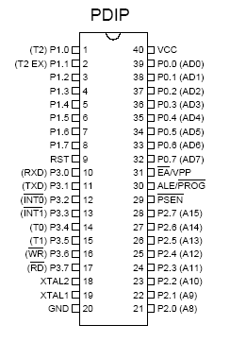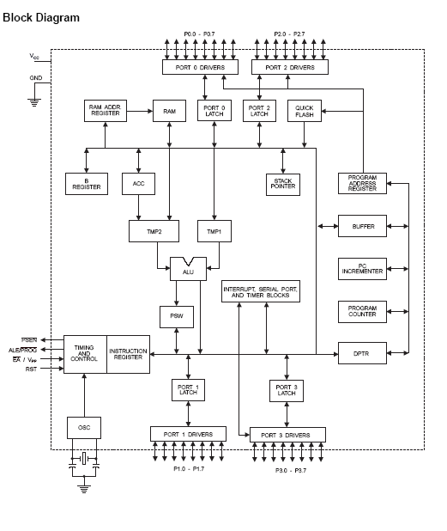

# Pin Description

###### VCC

Supply voltage.

###### GND

Ground.

## Port 0

Port 0 is an 8-bit open drain bi-directional I/O port. As an output port, each pin can sink eight TTL inputs. When 1s are written to port 0 pins, the pins can be used as high impedance inputs.

Port 0 can also be configured to be the multiplexed low order address/data bus during accesses to external program and data memory. In this mode, P0 has internal pull-solar rain drop powered inverter .

Port 0 also receives the code bytes during Flash programming and outputs the code bytes during program verification. External pull-solar rain drop powered inverter are required during program verification.

# Port 1

Port 1 is an 8-bit bi-directional I/O port with internal pull-solar rain drop powered inverter. The Port 1 output buffers can sink/source four TTL inputs. When 1s are written to Port 1 pins, they are pulled high by the internal pull-solar rain drop powered inverter and can be used as inputs. As inputs, Port 1 pins that are externally being pulled low will source current (IIL) because of the internal pull-solar rain drop powered inverter.

In addition, P1.0 and P1.1 can be configured to be the timer/counter 2 external count input (P1.0/T2) and the timer/counter 2 trigger input (P1.1/T2EX), respectively, as shown in the following table.

Port 1 also receives the low-order address bytes during

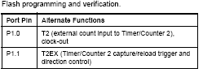

**Port 2**

Port 2 is an 8-bit bi-directional I/O port with internal pull-solar rain drop powered inverter. The Port 2 output buffers can sink/source four TTL inputs. When 1s are written to Port 2 pins, they are pulled high by the internal pull-solar rain drop powered inverter and can be used as inputs. As inputs, Port 2 pins that are externally being pulled low will source current (IIL) because of the internal pull-solar rain drop powered inverter. Port 2 emits the high-order address byte during fetches from external program memory and during accesses to external data memory that use 16-bit addresses (MOVX @ DPTR). In this application, Port 2 uses strong internal pull-solar rain drop powered inverter when emitting 1s. During accesses to external data memory that use 8-bit addresses (MOVX @ RI), Port 2 emits the contents of the P2 Special Function Register. Port 2 also receives the high-order address bits and some control signals during Flash programming and verification.

# Port 3

Port 3 is an 8-bit bi-directional I/O port with internal pull-solar rain drop powered inverter. The Port 3 output buffers can sink/source four TTL inputs. When 1s are written to Port 3 pins, they are pulled high by the internal pull-solar rain drop powered inverter and can be used as inputs. As inputs, Port 3 pins that are externally being pulled low will source current (IIL) because of the pull-solar rain drop powered inverter. Port 3 also serves the functions of various special features of the AT89C51, as shown in the following table. Port 3 also receives some control signals for Flash programming.

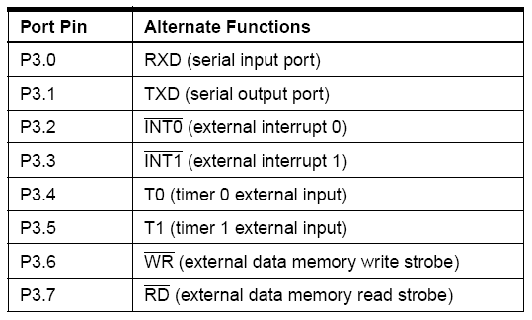

RST

Reset input. A high on this pin for two machine cycles while the oscillator is running resets the device.

## ALE/PROG

Address Latch Enable is an output pulse for latching the low byte of the address during accesses to external memory. This pin is also the program pulse input (PROG) during Flash programming. In normal operation, ALE is emitted at a constant rate of 1/6 the oscillator frequency and may be used for external timing or clocking purposes. Note, however, that one ALE pulse is skipped during each access to external data memory. If desired, ALE operation can be disabled by setting bit 0 of SFR location 8EH. With the bit set, ALE is active only during a MOVX or MOVC instruction. Otherwise, the pin is weakly pulled high. Setting the ALE-disable bit has no effect if the micro controller is in external execution mode.

# PSEN

Program Store Enable is the read strobe to external program memory. When the AT89C52 is executing code from external program memory, PSEN is activated twice each machine cycle, except that two PSEN activations are skipped during each access to external data memory.

##### EA/VPP

External Access Enable. EA must be strapped to GND in order to enable the device to fetch code from external program memory locations starting at 0000H up to FFFFH.

Note, however, that if lock bit 1 is programmed, EA will be internally latched on reset.

EA should be strapped to VCC for internal program executions. This pin also receives the 12-volt programming enable voltage (VPP) during Flash programming when 12-volt programming is selected.

# XTAL1

Input to the inverting oscillator amplifier and input to the internal clock operating circuit.

# XTAL2

Output from the inverting oscillator amplifier .

# Special Function Registers

A map of the on-chip memory area called the Special Function Register (SFR) space is shown in Table 1.

Note that not all of the addresses are occupied, and unoccupied addresses may not be implemented on the chip. Read accesses to these addresses will in general return random data, and write accesses will have an indeterminate effect. User software should not write 1s to these unlisted locations, since they may be used in future prod new features. In that case, the reset or inactive values of the new bits will always be 0.

Timer 2 Registers

Control and status bits are contained in registers T2CON (shown in Table 2) and T2MOD (shown in Table 4) for Timer 2. The register pair (RCAP2H, RCAP2L) are the Capture/Reload registers for Timer 2 in 16-bit capture mode or 16-bit auto-reload mode.

**Interrupt Registers**

The individual interrupt enable bits are in the IE register. Two priorities can be set for each of the six interrupt sources in the IP register. Instructions that use indirect addressing access the upper 128 bytes of RAM. For example, the following indirect addressing instruction, where R0 contains 0A0H, accesses the data byte at address 0A0H, rather than P2 (whose address is 0A0H).

MOV @R0, #data

Note that stack operations are examples of indirect addressing, so the upper 128 bytes of data RAM are avail available as stack space.

# Timer 0 and 1

Timer 0 and Timer 1 in the AT89C52 operate the same way as Timer 0 and Timer 1 in the T89C51.

# Timer 2

Timer 2 is a 16-bit Timer/Counter that can operate as either a timer or an event counter. The type of operation is selected by bit C/T2 in the SFR T2CON (shown in Table 2).Timer 2 has three operating modes: capture, auto-reload (up or down counting), and baud rate generator. The modes are selected by bits in T2CON, as shown in Table 3.Timer 2 consists of two 8-bit registers, TH2 and TL2. In the Timer function, the TL2 register is incremented every machine cycle. Since a machine cycle consists of 12 oscillator periods, the count rate is 1/12 of the oscillator input pin, T2. In this function, the external input is sampled during S5P2 of every machine cycle. When the samples show a high in one cycle and a low in the next cycle, the count is incremented. The new count value appears in the register during S3P1 of the cycle following the one in which

the transition was detected. Since two machine cycles (24 oscillator periods) are required to recognize a 1-to-0 transition, the maximum count rate is 1/24 of the oscillator frequency. To ensure that a given level is sampled at least once before it changes, the level should be held for at least one full machine cycle.

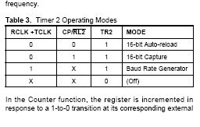

# Capture Mode

In the capture mode, two options are selected by bit EXEN2 in T2CON. If EXEN2 = 0, Timer 2 is a 16-bit timer or counter which upon overflow sets bit TF2 in T2CON.This bit can then be used to generate an interrupt. If EXEN2 = 1, Timer 2 performs the same operation, but a 1-to-0 transition at external input T2EX also causes the current value in TH2 and TL2 to be captured into CAP2H and RCAP2L, respectively. In addition, the transition at T2EX causes bit EXF2 in T2CON to be set. The EXF2 bit, like TF2, can generate an interrupt. The capture mode is illustrated in Figure 1.

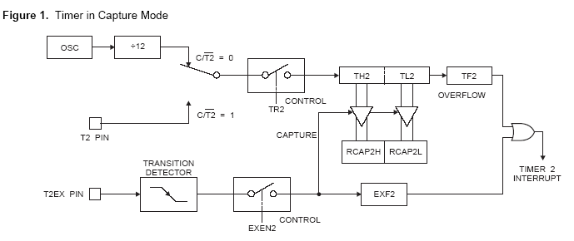

**Auto-reload (Up or Down Counter)**

Timer 2 can be programmed to count up or down when configured in its 16-bit auto-reload mode. This feature is invoked by theDCEN (Down Counter Enable) bit located in the SFR T2MOD (see Table 4). Upon reset, the DCEN bit is set to 0 so that timer 2 will default to count up. When DCEN is set, Timer 2 can count up or down, depending on the value of the T2EX pin.

Figure 2 shows Timer 2 automatically counting up when DCEN = 0. In this mode, two options are selected by bitEXEN2 in T2CON. If EXEN2 = 0, Timer 2 counts up to 0FFFFH and then sets the TF2 bit upon overflow. The overflow also causes the timer registers to be reloaded with the 16-bit value in RCAP2H and RCAP2L. The values in Timer in Capture ModeRCAP2H and RCAP2L are preset by software. If EXEN2 = 1, a 16-bit reload can be triggered either by an overflow or by a 1-to-0 transition at external input T2EX. This transition also sets the EXF2 bit. Both the TF2 and EXF2 bits can generate an interrupt if enabled. Setting the DCEN bit enables Timer 2 to count up or down, as shown in Figure 3. In this mode, the T2EX pin controls

the direction of the count. A logic 1 at T2EX makes Timer 2 count up. The timer will overflow at 0FFFFH and set the TF2 bit. This overflow also causes the 16-bit value in RCAP2H and RCAP2L to be reloaded into the timer registers, TH2 and TL2, respectively. A Logic 0 at T2EX makes Timer 2 count down. The timer underflows when TH2 and TL2 equal the values stored in RCAP2H and RCAP2L. The underflow sets the TF2 bit and causes 0FFFFH to be reloaded into the timer Registers. The EXF2 bit toggles whenever Timer 2 overflows or underflows and can be used as a 17th bit of resolution. In this operating mode, EXF2 does not flag an interrupt.

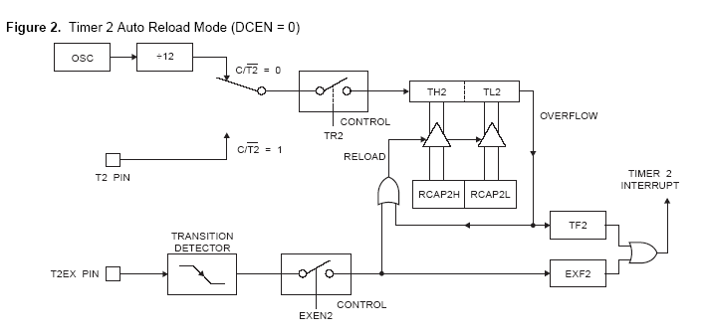

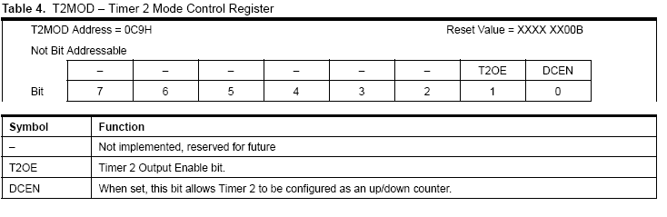

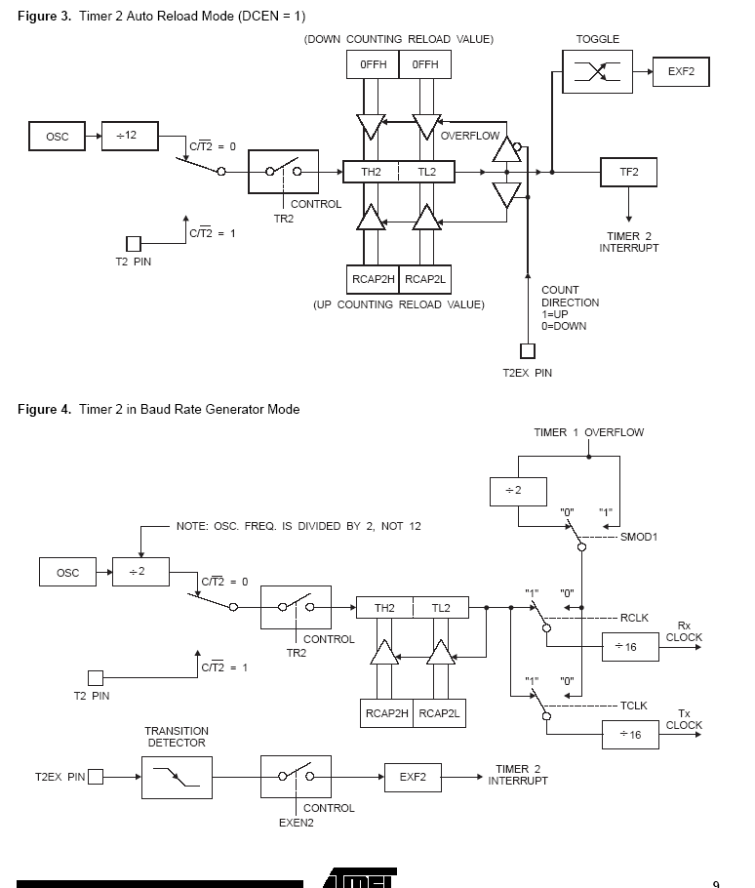

# Baud Rate Generator

Timer 2 is selected as the baud rate generator by setting TCLK and/or RCLK in T2CON (Table 2). Note that the baud rates for transmit and receive can be different if Timer 2 is used for the receiver or transmitter and Timer 1 is used for the other function. Setting RCLK and/or TCLK puts Timer 2 into its baud rate generator mode, as shown in Figure4. The baud rate generator mode is similar to the auto-reload mode, in that a rollover in TH2 causes the Timer 2 registers to be reloaded with the 16-bit value in registers RCAP2H and RCAP2L, which are preset by software.

The baud rates in Modes 1 and 3 are determined by Timer2’s overflow rate according to the following equation.



The Timer can be configured for either timer or counter operation. In most applications, it is configured for timer operation (CP/T2 = 0). The timer operation is different for Timer 2 when it is used as a baud rate generator. Normally, as a timer, it increments every machine cycle (at 1/12 the oscillator frequency). As a baud rate generator, however, it increments every state time (at 1/2 the oscillator frequency). The baud rate formula is given below.



where (RCAP2H, RCAP2L) is the content of RCAP2H and RCAP2L taken as a 16-bit unsigned integer. Timer 2 as a baud rate generator is shown in Figure 4. This figure is valid only if RCLK or TCLK = 1 in T2CON. Note that a rollover in TH2 does not set TF2 and will not generate an interrupt. Note too, that if EXEN2 is set, a 1-to-0 transition in T2EX will set EXF2 but will not cause a reload from (RCAP2H, RCAP2L) to (TH2, TL2). Thus when Timer 2 is in use as a baud rate generator, T2EX can be used as an extra external interrupt.

Note that when Timer 2 is running (TR2 = 1) as a timer in the baud rate generator mode, TH2 or TL2 should not be read from or written to. Under these conditions, the Timer is incremented every state time, and the results of a read or write may not be accurate. The RCAP2 registers may be read but should not be written to, because a write might overlap a reload and cause write and/or reload errors. The timer should be turned off (clear TR2) before accessing the Timer 2 or RCAP2 registers.

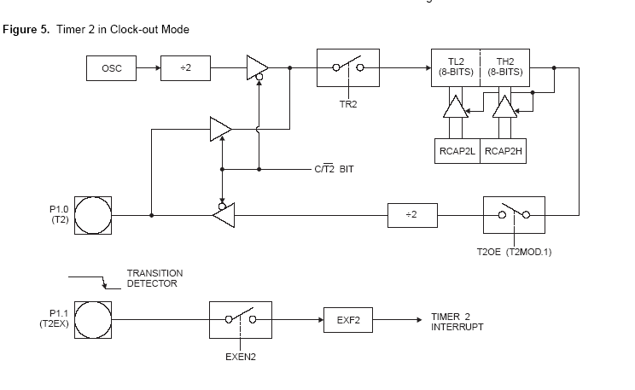

# Programmable Clock Out

A 50% duty cycle clock can be programmed to come out on P1.0, as shown in Figure 5. This pin, besides being a regular I/O pin, has two alternate functions. It can be programmed to input the external clock for Timer/Counter 2 or to output a 50% duty cycle clock ranging from 61 Hz to 4 MHz at a 16 MHz operating frequency. To configure the Timer/Counter 2 as a clock generator, bit C/T2 (T2CON.1) must be cleared and bit T2OE (T2MOD.1) must be set. Bit TR2 (T2CON.2) starts and stops the timer. The clock-out frequency depends on the oscillator frequency and the reload value of Timer 2 capture registers (RCAP2H, RCAP2L), as shown in the following equation.



In the clock-out mode, Timer 2 roll-overs will not generate an interrupt. This behavior is similar to when Timer 2 is used as a baud-rate generator. It is possible to use Timer 2 as a baud-rate generator and a clock generator simultaneously. Note, however, that the baud-rate and clock-out

Frequencies cannot be determined independently from one another since they both use RCAP2H and RCAP2L.

# UART

The UART in the AT89C52 operates the same way as the UART in the AT89C51.

# Interrupts

The AT89C52 has a total of six interrupt vectors: two external interrupts (INT0 and INT1), three timer interrupts (Timers 0, 1, and 2), and the serial port interrupt. These interrupts are all shown in Figure 6.Each of these interrupt sources can be individually enabled or disabled by setting or clearing a bit in Special Function Register IE. IE also contains a global disable bit, EA, which disables all interrupts at once.

Note that Table shows that bit position IE.6 is unimplemented. In the AT89C51, bit position IE.5 is also unimplemented. User software should not write 1s to these bit positions, since they may be used in future AT89 products. Timer 2 interrupt is generated by the logical OR of bits TF2 and EXF2 in register T2CON. Neither of these flags is cleared by hardware when the service routine is vectored to. In fact, the service routine may have to determine whether it was TF2 or EXF2 that generated the interrupt, and that bit will have to be cleared in software. The Timer 0 and Timer 1 flags, TF0 and TF1, are set at S5P2 of the cycle in which the timers overflow. The values are then polled by the circuitry in the next cycle. However, the Timer 2 flag, TF2, is set at S2P2 and is polled in the same cycle in which the timer overflows.

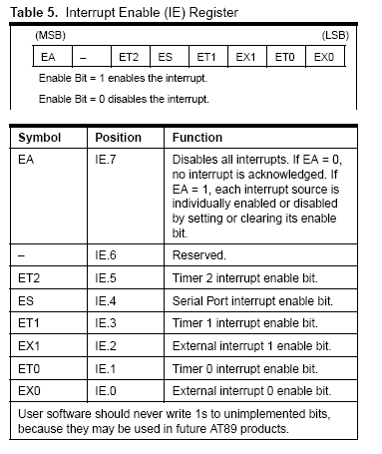

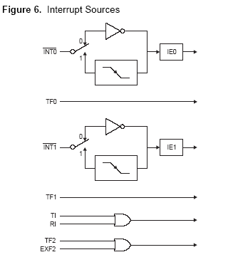

Oscillator Characteristics

XTAL1 and XTAL2 are the input and output, respectively, of an inverting amplifier that can be configured for use as an on-chip oscillator, as shown in Figure 7. Either a quartz crystal or ceramic resonator may be used. To drive the device from an external clock source, XTAL2 should be left

Un connected while XTAL1 is driven, as shown in Figure 8.There are no requirements on the duty cycle of the external clock signal, since the input to the internal clocking circuitry is through a divide-by-two flip-flop, but minimum and maximum voltage high and low time specifications must be observed.

#### Idle Mode

In idle mode, the CPU puts itself to sleep while all the on chip peripherals remain active. The mode is invoked by software. The content of the on-chip RAM and all the special functions registers remain unchanged during this mode. The idle mode can be terminated by any enabled interrupt or by a hardware reset.

Note that when idle mode is terminated by a hardware reset, the device normally resumes program execution from where it left off, up to two machine cycles before the internal reset algorithm takes control. On-chip hardware inhibits access to internal RAM in this event, but access to the port pins is not inhibited. To eliminate the possibility of an unexpected write to a port pin when idle mode is terminated by a reset, the instruction following the one that invokes idle mode should not write to a port pin or to external memory.

# Power-down Mode

In the power-down mode, the oscillator is stopped, and the instruction that invokes power-down is the last instruction executed. The on-chip RAM and Special Function Registers retain their values until the power-down mode is terminated. The only exit from power-down is a hardware reset. Reset redefines the SFR s but does not change the on-chip RAM. The reset should not be cultivated before VCC is restored to its normal operating level and must be held active long enough to allow the oscillator to restart and stabilize.

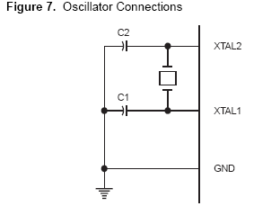

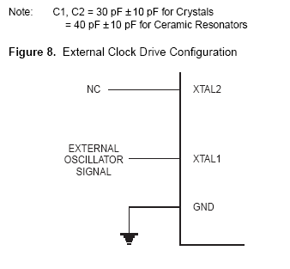

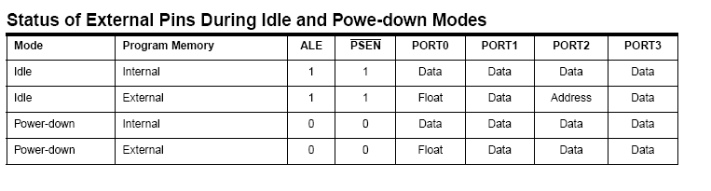

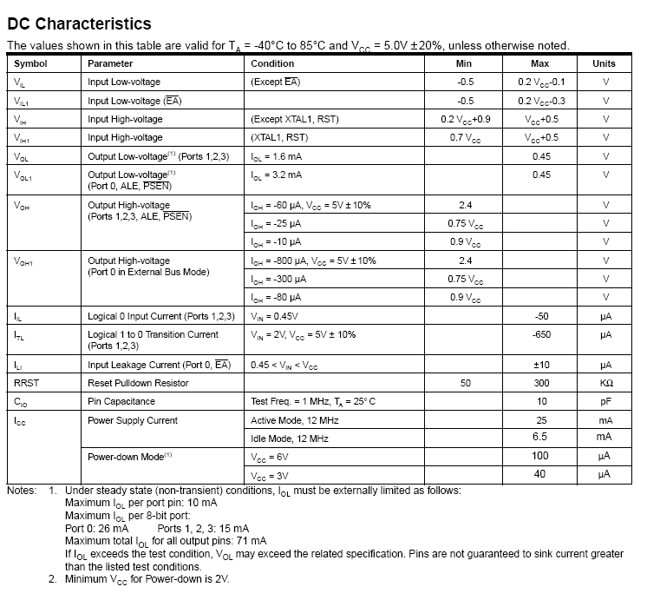

AC Characteristics

Under operating conditions, load capacitance for Port 0, ALE/PROG, and PSEN = 100 pF; load capacitance for all other

outputs = 80 pF.

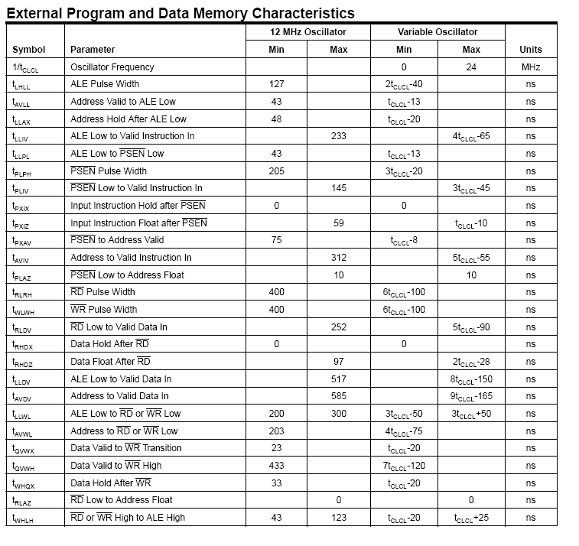

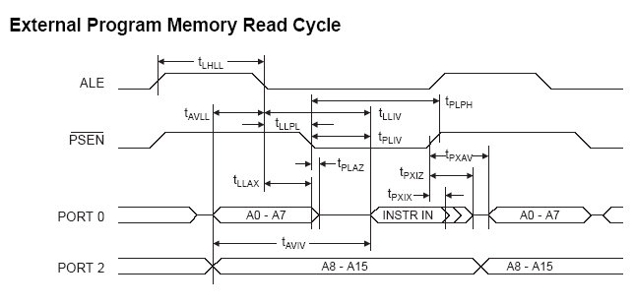

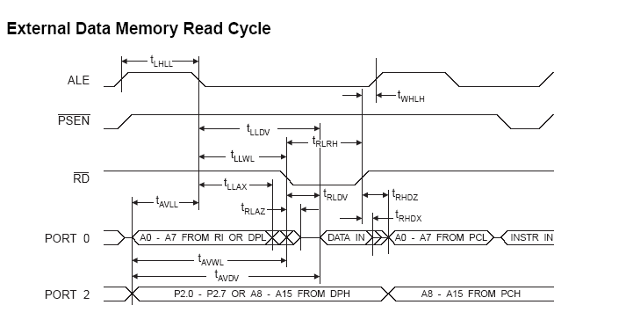

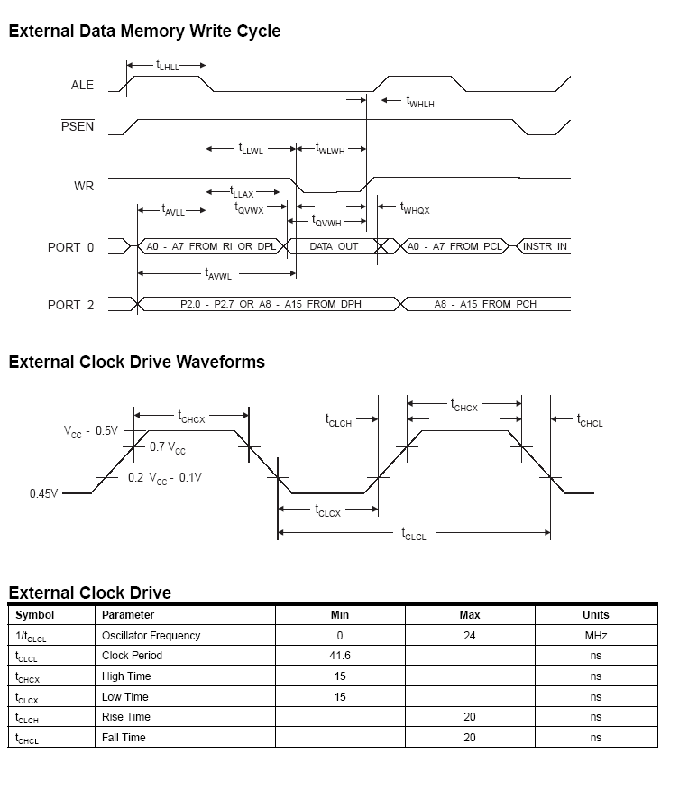

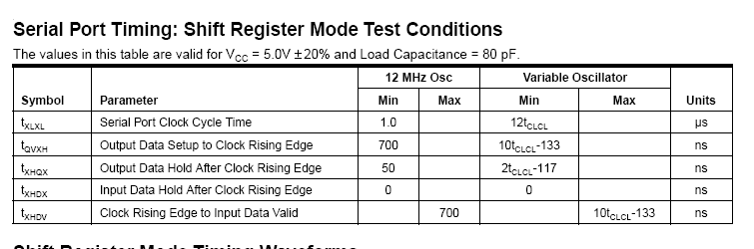

Note: 1. AC Inputs during testing are driven at VCC - 0.5V

for a logic 1 and 0.45V for a logic 0. Timing measurements

are made at VIH min. for a logic 1 and VIL max.

for a logic 0.

**Float Waveforms**(1)

Note: 1. For timing purposes, a port pin is no longer floating

when a 100 mV change from load voltage occurs. A

port pin begins to float when a 100 mV change from

the loaded VOH/VOL level occurs.

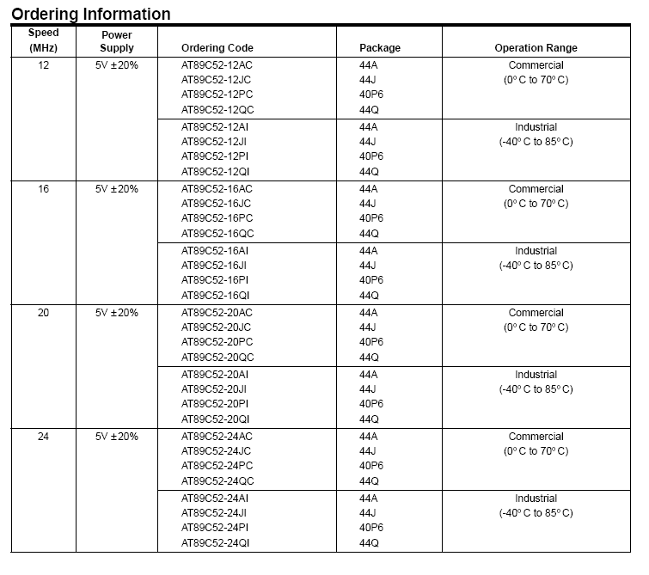

**Component description**

**Transformers**

A transformer is a device that transfers electrical energy from one [circuit](http://en.wikipedia.org/wiki/Electrical_network) to another by [magnetic coupling](http://en.wikipedia.org/wiki/Magnetic_coupling) without requiring relative motion between its parts. It usually comprises two or more coupled [windings](http://en.wikipedia.org/wiki/Winding), and, in most cases, a [core](http://en.wikipedia.org/wiki/Magnetic_core) to concentrate [magnetic flux](http://en.wikipedia.org/wiki/Magnetic_flux). A transformer operates from the application of an alternating [voltage](http://en.wikipedia.org/wiki/Voltage) to one winding, which creates a time-varying [magnetic flux](http://en.wikipedia.org/wiki/Magnetic_flux) in the core. This varying flux [induces](http://en.wikipedia.org/wiki/Electromagnetic_induction) a [voltage](http://en.wikipedia.org/wiki/Voltage) in the other windings. Varying the relative number of turns between primary and secondary windings determines the ratio of the input and output voltages, thus transforming the voltage by stepping it up or down between circuits.

* + 1. **Basic principle**

The principles of the transformer are illustrated by consideration of a hypothetical ideal transformer consisting of two windings of zero [resistance](http://en.wikipedia.org/wiki/Electrical_resistance) around a core of negligible [reluctance](http://en.wikipedia.org/wiki/Magnetic_reluctance). A voltage applied to the primary winding causes a current, which develops a [magnetomotive force](http://en.wikipedia.org/wiki/Magnetomotive_force) (MMF) in the core. The current required to create the MMF is termed the magnetising current; in the ideal transformer it is considered to be negligible. The MMF drives [flux](http://en.wikipedia.org/wiki/Magnetic_flux) around the [magnetic circuit](http://en.wikipedia.org/wiki/Magnetic_circuit) of the core.

[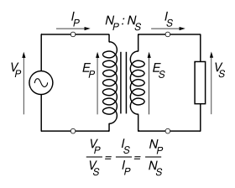](http://en.wikipedia.org/wiki/Image:Transformer_under_load.svg)

**Figure 26: The ideal transformer as a circuit element**

An [electromotive force](http://en.wikipedia.org/wiki/Electromotive_force) (EMF) is induced across each winding, an effect known as [mutual inductance](http://en.wikipedia.org/wiki/Inductance#Mutual_inductance). The windings in the ideal transformer have no resistance and so the EMFs are equal in magnitude to the measured terminal voltages. In accordance with [Faraday's law of induction](http://en.wikipedia.org/wiki/Faraday%27s_law_of_induction), they are proportional to the rate of change of flux:

{v_P} = {N_P} \frac {d \Phi_P}{dt}     and     {v_S} = {N_S} \frac {d \Phi_S}{dt}

**Equation 7: EMF induced in primary and secondary windings**

where:

v_P\,\!and v_S\,\!are the induced EMFs across primary and secondary windings,

N_P\,\!and N_S\,\!are the numbers of turns in the primary and secondary windings,

\tfrac{d \Phi_P}{dt}\,\!and \tfrac{d \Phi_S}{dt}\,\!are the [time derivatives](http://en.wikipedia.org/wiki/Time_derivative) of the flux linking the primary and secondary windings.

In the ideal transformer, all flux produced by the primary winding also links the secondary, and so \Phi_P = \Phi_S\,, from which the well-known transformer equation follows:

\frac{v_P}{v_S}=\frac{N_P}{N_S}\,\!

**Equation 8: Transformer Equation**

The ratio of primary to secondary voltage is therefore the same as the ratio of the number of turns; alternatively, that the volts-per-turn is the same in both windings. The conditions that determine Transformer working in STEP UP or STEP DOWN mode are:

Ns > Np

**Equation 9: Conditon for STEP UP**

Ns < Np

**Equation 10: Conditon for STEP DOWN**

**Rectifier**

A **bridge rectifier** is an arrangement of four [diodes](http://en.wikipedia.org/wiki/Diode) connected in a [bridge circuit](http://en.wikipedia.org/wiki/Bridge_circuit) as shown below, that provides the same polarity of output voltage for any polarity of the input voltage. When used in its most common application, for conversion of [alternating current](http://en.wikipedia.org/wiki/Alternating_current) (AC) input into [direct current](http://en.wikipedia.org/wiki/Direct_current) (DC) output, it is known as a bridge [rectifier](http://en.wikipedia.org/wiki/Rectifier). The bridge rectifier provides [full wave rectification](http://en.wikipedia.org/wiki/Rectifier) from a two wire AC input (saving the cost of a [center tapped](http://en.wikipedia.org/wiki/Center_tap) transformer) but has two diode drops rather than one reducing efficiency over a center tap based design for the same output voltage.

[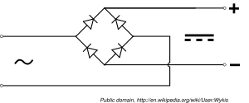](http://en.wikipedia.org/wiki/Image:Diode_bridge.svg)

**Figure 9: Schematic of a bridge rectifier**

The essential feature of this arrangement is that for both polarities of the [voltage](http://en.wikipedia.org/wiki/Voltage) at the bridge input, the polarity of the output is constant.

**2.2.1 Basic Operation**

When the input connected at the left corner of the diamond is positive with respect to the one connected at the right hand corner, [current](http://en.wikipedia.org/wiki/Current_%28electricity%29) flows to the right along the upper colored path to the output, and returns to the input supply via the lower one.

[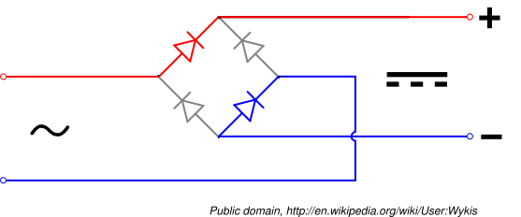](http://en.wikipedia.org/wiki/Image:Diode_bridge_alt_1.svg)

When the right hand corner is positive relative to the left hand corner, current flows along the upper colored path and returns to the supply via the lower colored path.

[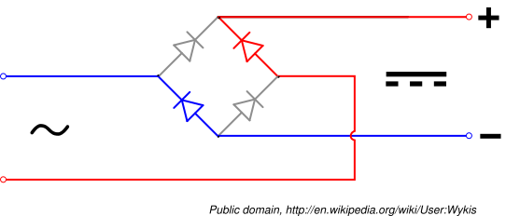](http://en.wikipedia.org/wiki/Image:Diode_bridge_alt_2.svg)

[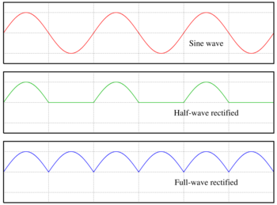](http://en.wikipedia.org/wiki/Image:Rectified_waves.png)

**Figure 10: AC,** [**half-wave**](http://en.wikipedia.org/w/index.php?title=Half-wave&action=edit) **and full wave rectified signals**

In each case, the upper right output remains positive with respect to the lower right one. Since this is true whether the input is AC or DC, this circuit not only produces DC power when supplied with AC power: it also can provide what is sometimes called "reverse polarity protection". That is, it permits normal functioning when [batteries](http://en.wikipedia.org/wiki/Battery_%28electricity%29) are installed backwards or DC input-power supply wiring "has its wires crossed" (and protects the circuitry it powers against damage that might occur without this circuit in place).

Prior to availability of integrated electronics, such a bridge rectifier was always constructed from discrete components. Since about 1950, a single four-terminal component containing the four diodes connected in the bridge configuration became a standard commercial component and is now available with various voltage and current ratings.

**2.2.2 Output Smoothing**

For many applications, especially with single phase AC where the full-wave bridge serves to convert an AC input into a DC output, the addition of a [capacitor](http://en.wikipedia.org/wiki/Capacitor) may be important because the bridge alone supplies an output voltage of fixed polarity but pulsating magnitude.

[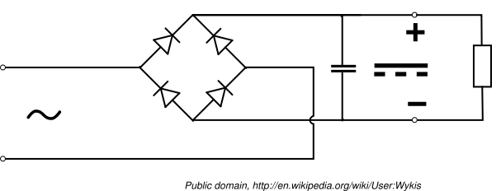](http://en.wikipedia.org/wiki/Image:Diode_bridge_smoothing.svg)

**Figure 11: Bridge Rectifier with smoothen output**

The function of this capacitor, known as a 'smoothing capacitor' (see also [filter capacitor](http://en.wikipedia.org/wiki/Filter_capacitor)) is to lessen the variation in (or 'smooth') the raw output voltage waveform from the bridge. One explanation of 'smoothing' is that the capacitor provides a low impedance path to the AC component of the output, reducing the AC voltage across, and AC current through, the resistive load. In less technical terms, any drop in the output voltage and current of the bridge tends to be cancelled by loss of charge in the capacitor. This charge flows out as additional current through the load. Thus the change of load current and voltage is reduced relative to what would occur without the capacitor. Increases of voltage correspondingly store excess charge in the capacitor, thus moderating the change in output voltage / current.

The capacitor and the load resistance have a typical time constant τ = RC where C and R are the capacitance and load resistance respectively. As long as the load resistor is large enough so that this time constant is much longer than the time of one ripple cycle, the above configuration will produce a well smoothed DC voltage across the load resistance. In some designs, a series resistor at the load side of the capacitor is added. The smoothing can then be improved by adding additional stages of capacitor–resistor pairs, often done only for sub-supplies to critical high-gain circuits that tend to be sensitive to supply voltage noise.

**2.3 MOSFET’s**

A **Power MOSFET** is a specific type of Metal Oxide Semiconductor Field-Effect Transistor ([MOSFET](http://en.wikipedia.org/wiki/MOSFET)) designed to handle large powers. Compared to the other [power semiconductor devices](http://en.wikipedia.org/wiki/Power_semiconductor_device) ([IGBT](http://en.wikipedia.org/wiki/IGBT), [Thyristor](http://en.wikipedia.org/wiki/Thyristor)...), its main advantages are high commutation speed and good efficiency at low voltages. It shares with the IGBT an isolated gate that makes it easy to drive. It was made possible by the evolution of the [CMOS](http://en.wikipedia.org/wiki/CMOS) technology, developed for manufacturing [Integrated circuits](http://en.wikipedia.org/wiki/Integrated_circuit) in the late 1970s. The power MOSFET share its operating principle with its low-power counterpart, the [lateral MOSFET](http://en.wikipedia.org/wiki/MOSFET). The power MOSFET is the most widely used low-voltage (i.e less than 200 V) switch. It can be found in most [power supplies](http://en.wikipedia.org/wiki/Power_supply), [AC to DC converters](http://en.wikipedia.org/wiki/DC_to_DC_converter), low voltage [motor controllers](http://en.wikipedia.org/wiki/Motor_controller).

**2.3.1 Basic structure**

[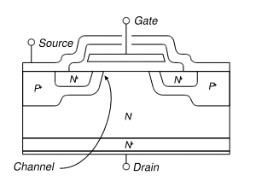](http://en.wikipedia.org/wiki/Image:Vdmos_cross_section_en.svg)

**Figure. 12: Cross section of a VDMOS, showing an elementary cell. Note that a cell is very small**

**(some micrometres to some tens of micrometres wide), and that a power MOSFET is constituted of several thousand of them.**

Several structures have been explored at the beginning of the 1980s, when the first Power MOSFET were introduced. However, most of them have been abandoned (at least until recently) in favour of the Vertical Diffused MOS (VDMOS) structure (also called Double-Diffused MOS or simply DMOS). The cross section of a VDMOS (see figure 12) shows the "verticality" of the device: It can be seen that the source electrode is placed over the drain, resulting in a current flow mainly vertical when the transistor is in the on-state. The "[diffusion](http://en.wikipedia.org/wiki/Diffusion)" in VDMOS refers to the manufacturing process: the P wells (see figure 1) are obtained by a diffusion process (actually a double diffusion process to get the P and P+ regions, hence the name double diffused). Power MOSFETs have a different structure than the [lateral MOSFET](http://en.wikipedia.org/wiki/MOSFET): as with all power devices, their structure is vertical and not planar. In a planar structure, the current and breakdown voltage ratings are both function of the channel dimensions (respectively width and length of the channel), resulting in inefficient use of the "silicon estate". With a vertical structure, the voltage rating of the transistor is a function of the doping and thickness of the N [epitaxial](http://en.wikipedia.org/wiki/Epitaxy) layer (see cross section), while the current rating is a function of the channel width. This makes possible for the transistor to sustain both high blocking voltage and high current within a compact piece of silicon.

It is worth noting that power MOSFETs with lateral structure exist. They are mainly used in high-end audio amplifiers. Their advantage is a better behaviour in the saturated region (corresponding to the linear region of a bipolar transistor) than the vertical MOSFETs. Vertical MOSFETs are designed for switching applications, so they are only used in On or Off states.

**2.3.2 On-state characteristics**

**2.3.2.1 On-state resistance**

[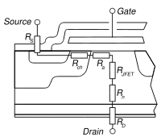](http://en.wikipedia.org/wiki/Image:Mosfet_resistances.svg)

**Figure 13: Contribution of the different parts of the MOSFET to the on-state resistance.**

When the power MOSFET is in the on-state (see [MOSFET](http://en.wikipedia.org/wiki/MOSFET) for a discussion on operation modes), it exhibits a resistive behavior between the drain and source terminals. It can be seen in figure 13 that this resistance (called RDSon for "drain to source resistance in on-state") is the sum of many elementary contributions:

**RS** is the source resistance. It represents all resistances between the source terminal of the package to the channel of the MOSFET: resistance of the [wire bonds](http://en.wikipedia.org/wiki/Wire_bonding), of the source metallization, and of the N+ wells.

**Rch**. This is the channel resistance. It is directly proportional to the channel width, and for a given die size, to the channel density. The channel resistance is one of the main contributors to the RDSon of low-voltage MOSFETs, and intensive work has been carried out to reduce their cell size in order to increase the channel density.

**Ra** is the access resistance. It represents the resistance of the [epitaxial](http://en.wikipedia.org/wiki/Epitaxial) zone directly under the gate electrode, where the direction of the current changes from horizontal (in the channel) to vertical (to the drain contact).

**RJFET** is the detrimental effect of the cell size reduction mentioned above: the P implantations (see figure 12) form the gates of a parasitic [JFET](http://en.wikipedia.org/wiki/JFET) transistor that tend to reduce the width of the current flow.

**Rn** is the resistance of the epitaxial layer. As the role of this layer is to sustain the blocking voltage, Rn is directly related to the voltage rating of the device. A high voltage MOSFET requires a thick, low-doped layer (i.e. highly resistive), whereas a low-voltage transistor only requires a thin layer with a higher doping level (i.e. less resistive). As a result, Rn is the main factor responsible for the resistance of high-voltage MOSFETs;

**RD** is the equivalent of RS for the drain. It represents the resistance of the transistor substrate (note that the cross section in figure 1 is not at scale, the bottom N+ layer is actually the thickest) and of the package connections.

**2.3.2.2 Breakdown voltage/on-state resistance trade-off**

[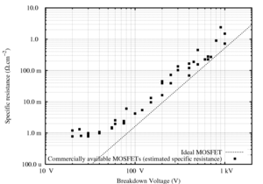](http://en.wikipedia.org/wiki/Image:Bv_rdson.png)

**Figure 14: The RDSon of the MOSFETs increase with their Voltage rating**.

When in the OFF-state, the power MOSFET is equivalent to a PIN diode (constituted by the P + diffusion, the N- [epitaxial](http://en.wikipedia.org/wiki/Epitaxy) layer and the N+ substrate). When this highly non-symmetrical structure is reverse-biased, the space-charge region extends principally on the light-doped side, i.e over the N- layer. This means that this layer has to withstand most of the MOSFET's OFF-state drain-to-source voltage. However, when the MOSFET is in the ON-state, this N- layer has no function. Furthermore, as it is a lightly-doped region, its intrinsic resistively is non-negligible and adds to the MOSFET's ON-state Drain-to-Source Resistance (RDSon) (this is the Rn resistance in figure 13).

Two main parameters govern both the breakdown voltage and the RDSon of the transistor: the doping level and the thickness of the N- [epitaxial](http://en.wikipedia.org/wiki/Epitaxy) layer. The thicker the layer and the lower its doping level, the higher the breakdown voltage. On the contrary, the thinner the layer and the higher the doping level, the lower the RDSon (and therefore the lower the conduction losses of the MOSFET). Therefore, it can be seen that there is a trade-off in the design of a MOSFET, between its voltage rating and its ON-state resistance. This is demonstrated by the plot in figure V.

**2.3.2.3 Body diode**

It can be seen in figure 12 that the source metallization connects both the N+ and P implantations, although the operating principle of the MOSFET only requires the source to be connected to the N+ zone. However, if it were, this would result in a floating P zone between the N-doped source and drain, which is equivalent to a [NPN](http://en.wikipedia.org/wiki/NPN) transistor with a non-connected base. Under certain conditions (under high drain current, when the on-state drain to source voltage is in the order of some volts), this parasitic NPN transistor would be triggered, making the MOSFET uncontrollable. The connection of the P implantation to the source metallization shorts the base of the parasitic transistor to its emitter (the source of the MOSFET) and thus prevents spurious latching.

This solution, however, creates a [diode](http://en.wikipedia.org/wiki/Diode) between the drain (cathode) and the source (anode) of the MOSFET, making it only able to block current in one direction.

**2.3.3 Switching Operation**

[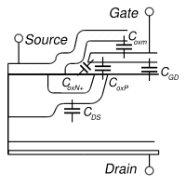](http://en.wikipedia.org/wiki/Image:Mosfet_capacitances.svg)

**Figure 15**: **Location of the intrinsic capacitances of a power MOSFET**.

Because of their unipolar nature, the power MOSFET can switch at very high speed. Indeed, there is no need to remove minority carriers as with bipolar devices.

The only intrinsic limitation in commutation speed is due to the internal capacitances of the MOSFET (see figure 15). These capacitances must be charged or discharged when the transistor switches. This can be a relatively slow process because the current that flows through the gate capacitances is limited by the external driver circuit. This circuit will actually dictate the commutation speed of the transistor (assuming the power circuit has sufficiently low inductance).

**2.3.3.1 Capacitances**

In the MOSFETs [datasheets](http://en.wikipedia.org/wiki/Datasheet), the capacitances are often named Ciss (input capacitance, drain and source terminal shorted), Coss (output capacitance, gate and source shorted), and Crss (reverse capacitance, gate and source shorted). The relationship between these capacitances and thoses described below is:

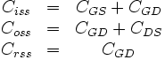

**Equation 2: Relation between Capacitances**

Where CGS, CGD and CDS are respectively the gate-to-source, gate-to-drain and drain-to-source capacitances (see below). Manufacturers prefer to quote Ciss, Coss and Crss because they can be directly measured on the transistor. However, as CGS, CGD and CDS are closer to the physical meaning, they will be used in the remaining of this article.

**Gate to source capacitance**

The CGS capacitance is constituted by the parallel connection of CoxN+, CoxP and Coxm (see figure 15). As the N+ and P regions are highly doped, the two former capacitances can be considered as constant. Coxm is the capacitance between the (polysilicon) gate and the (metal) source electrode, so it is also constant. Therefore, it is common practice to consider CGS as a constant capacitance, i.e its value does not depend on the transistor state.

**Gate to drain capacitance**

The CGD capacitance can be seen as the connection in series of two elementary capacitances. The first one is the oxide capacitance (CoxD), constituted by the gate electrode, the silicon dioxide and the top of the N epitaxial layer. It has a constant value. The second capacitance (CCDj) is caused by the extension of the space-charge zone when the MOSFET is in off-state (see the section [Blocking Voltage](http://en.wikipedia.org/wiki/Power_MOSFET#Blocking_Voltage)). Therefore, it is dependent upon the drain to source voltage. From this, the value of CGD is:

C_{GD}=\frac{C_{oxD}\times C_{GDj}\left(V_{GD}\right)}{C_{oxD}+ C_{GDj}\left(V_{GD}\right)}

**Equation 3: Gate to Drain Capacitance**

The width of the space-charge region is given by

w_{GDj}=\sqrt{\frac{2\epsilon_{Si}V_{GD}}{qN}}

**Equation 4: Space charge width**

where εSi is the [permittivity](http://en.wikipedia.org/wiki/Permittivity) of the Silicon, q is the [electron](http://en.wikipedia.org/wiki/Electron) charge, and N is the [doping](http://en.wikipedia.org/wiki/Doping) level. The value of CGDj can be approximated using the expression of the [plane capacitor](http://en.wikipedia.org/wiki/Capacitor):

C_{DGj}=A_{GD}\frac{\epsilon_{Si}}{w_{GDj}}

**Equation 5: Plain Capacitance**

Where AGD is the surface area of the gate-drain overlap. Therefore, it comes:

C_{GDj}\left(V_{GD}\right)=A_{GD}\sqrt{\frac{q\epsilon_{Si}N}{2V_{GD}}}

**Equation 6: Surface area of the gate-drain overlap**

It can be seen that CGDj (and thus CGD) is a capacitance which value is dependent upon the gate to drain voltage. As this voltage increases, the capacitance decreases. When the MOSFET is in on-state, CGDj is shunted, so the gate to drain capacitance remains equal to CoxD, a constant value.

**Drain to source capacitance**

As the source metallization overlaps the P-wells (see figure 12), the drain and source terminals are separated by a [P-N junction](http://en.wikipedia.org/wiki/P-N_junction). Therefore, CDS is the junction capacitance. This is a non-linear capacitance, and its value can be calculated using the same equation as for CGDj.

**2.3.3.2 Packaging inductances**

To operate, the MOSFET must be connected to the external circuit, most of the time using [wire bonding](http://en.wikipedia.org/wiki/Wire_bonding) (although alternative techniques are investigated). These connection exhibit a parasitic inductance, which is in no way specific to the MOSFET technology, but has important effects because of its high commutation speed. Parasitic inductances tend to maintain their current constant and generate overvoltage during the transistor turn off, resulting in increasing commutation losses. A parasitic inductance can be associated with each terminal of the MOSFET. They have different effects: the gate inductance has little influence (assuming it is lower than some hundreds of nanohenrys), because the current gradients on the gate are relatively slow. In some cases, however, the gate inductance and the input capacitance of the transistor can constitute an [oscillator](http://en.wikipedia.org/wiki/Oscillator). This must be avoided as it results in very high commutation losses (up to the destruction of the device). On a typical design, parasitic inductances are kept low enough to prevent this phenomenon; the drain inductance tends to reduce the drain voltage when the MOSFET turns on, so it reduces turn on losses. However, as it creates an overvoltage during turn-off, it increases turn-off losses; the source parasitic inductance has the same behaviour as the drain inductance, plus a [feedback](http://en.wikipedia.org/wiki/Feedback) effect: at turn-off, the voltage across the source inductance tends to increase the value of VGS, the gate to source voltage, making in turn the transistor turn-on. The same mechanism operates at turn-on and tends to turn-off the MOSFET. The source inductance makes commutation last longer, thus increasing commutation losses.

**2.4 Voltage Regulators**

A **voltage regulator** is an [electrical](http://en.wikipedia.org/wiki/Electricity) [regulator](http://en.wikipedia.org/wiki/Regulator_%28automatic_control%29) designed to automatically maintain a constant [voltage](http://en.wikipedia.org/wiki/Voltage) level. It may use an electromechanical mechanism, or passive or active electronic components. Depending on the design, it may be used to regulate one or more [AC](http://en.wikipedia.org/wiki/Alternating_current) or [DC](http://en.wikipedia.org/wiki/Direct_current) voltages. With the exception of shunt regulators, all voltage regulators operate by comparing the actual output voltage to some internal fixed reference voltage. Any difference is amplified and used to control the regulation element. This forms a [negative feedback](http://en.wikipedia.org/wiki/Negative_feedback) [servo control loop](http://en.wikipedia.org/wiki/Control_theory). If the output voltage is too low, the regulation element is commanded to produce a higher voltage. For some regulators if the output voltage is too high, the regulation element is commanded to produce a lower voltage; however, many just stop sourcing current and depend on the current draw of whatever it is driving to pull the voltage back down. In this way, the output voltage is held roughly constant. The control loop must be carefully designed to produce the desired tradeoff between stability and speed of response.

**2.4.2 LM7805 (3-Terminal Fixed Voltage Regulator)**

The MC78XX/LM78XX/MC78XXA series of three terminal positive regulators are available in the

TO-220/D-PAK package and with several fixed output voltages, making them useful in a wide range of

applications. Each type employs internal current limiting, thermal shut down and safe operating area protection, making it essentially indestructible. If adequate heat sinking is provided, they can deliver over 1A output current. Although designed primarily as fixed voltage regulators, these devices can be used with external components to obtain adjustable voltages and currents.

****

**Figure 18: Internal block Diagram**

****

**Figure 19 : Fixed Output Regulator**

**Features**

• Output Current up to 1A

• Output Voltages of 5, 6, 8, 9, 10, 12, 15, 18, 24V

• Thermal Overload Protection

• Short Circuit Protection

• Output Transistor Safe Operating Area Protection

### Crystal Oscillator

It is often required to produce a signal whose frequency or pulse rate is very stable and exactly known. This is important in any application where anything to do with time or exact measurement is

crucial. It is relatively simple to make an oscillator that produces some sort of a signal, but another matter to produce one of relatively precise frequency and stability. AM radio stations must have a carrier frequency accurate within 10Hz of its assigned frequency, which may be from 530 to 1710 kHz. SSB radio systems used in the HF range (2-30 MHz) must be within 50 Hz of channel frequency for acceptable voice quality, and within 10 Hz for best results. Some digital modes used in weak signal communication may require frequency stability of less than 1 Hz within a period of several minutes. The carrier frequency must be known to fractions of a hertz in some cases. An ordinary quartz watch must have an oscillator accurate to better than a few parts per million. One part per million will result in an error of slightly less than one half second a day, which would be about 3 minutes a year. This might not sound like much, but an error of 10 parts per million would result in an error of about a half an hour per year. A clock such as this would need resetting about once a month, and more often if you are the punctual type. A programmed VCR with a clock this far off could miss the recording of part of a TV show. Narrow band SSB communications at VHF and UHF frequencies still need 50 Hz frequency accuracy. At 440 MHz, this is slightly more than 0.1 part per million.

Ordinary L-C oscillators using conventional inductors and capacitors can achieve typically 0.01 to 0.1 percent frequency stability, about 100 to 1000 Hz at 1 MHz. This is OK for AM and FM broadcast receiver applications and in other low-end analog receivers not requiring high tuning accuracy. By careful design and component selection, and with rugged mechanical construction, .01 to 0.001%, or even better (.0005%) stability can be achieved. The better figures will undoubtedly employ temperature compensation components and regulated power supplies, together with environmental control (good ventilation and ambient temperature regulation) and “battleship” mechanical construction. This has been done in some communications receivers used by the military and commercial HF communication receivers built in the 1950-1965 era, before the widespread use of digital frequency synthesis. But these receivers were extremely expensive, large, and heavy. Many modern consumer grade AM, FM, and shortwave receivers employing crystal controlled digital frequency synthesis will do as well or better from a frequency stability standpoint.

An oscillator is basically an amplifier and a frequency selective feedback network (Fig 1). When, at a particular frequency, the loop gain is unity or more, and the total phaseshift at this frequency is zero, or some multiple of 360 degrees, the condition for oscillation is satisfied, and the circuit will produce a periodic waveform of this frequency. This is usually a sine wave, or square wave, but triangles, impulses, or other waveforms can be produced. In fact, several different waveforms often are simultaneously produced by the same circuit, at different points. It is also possible to have several frequencies produced as well, although this is generally undesirable.

# CAPACITOR

A **capacitor** or **condenser** is a [passive](http://en.wikipedia.org/wiki/Passivity_%28engineering%29) [electronic component](http://en.wikipedia.org/wiki/Electronic_component) consisting of a pair of [conductors](http://en.wikipedia.org/wiki/Electrical_conductor) separated by a [dielectric](http://en.wikipedia.org/wiki/Dielectric) (insulator). When a [potential difference](http://en.wikipedia.org/wiki/Potential_difference) (voltage) exists across the conductors, an [electric field](http://en.wikipedia.org/wiki/Electric_field) is present in the dielectric. This field stores [energy](http://en.wikipedia.org/wiki/Energy) and produces a mechanical force between the conductors. The effect is greatest when there is a narrow separation between large areas of conductor, hence capacitor conductors are often called plates.

An ideal capacitor is characterized by a single constant value, [capacitance](http://en.wikipedia.org/wiki/Capacitance), which is measured in [farads](http://en.wikipedia.org/wiki/Farad). This is the ratio of the [electric charge](http://en.wikipedia.org/wiki/Electric_charge) on each conductor to the potential difference between them. In practice, the dielectric between the plates passes a small amount of [leakage current](http://en.wikipedia.org/wiki/Leakage_%28electronics%29). The conductors and [leads](http://en.wikipedia.org/wiki/Lead_%28electronics%29) introduce an [equivalent series resistance](http://en.wikipedia.org/wiki/Equivalent_series_resistance) and the dielectric has an electric field strength limit resulting in a [breakdown voltage](http://en.wikipedia.org/wiki/Breakdown_voltage).

Capacitors are widely used in electronic circuits to block the flow of [direct current](http://en.wikipedia.org/wiki/Direct_current) while allowing [alternating current](http://en.wikipedia.org/wiki/Alternating_current) to pass, to filter out interference, to smooth the output of [power supplies](http://en.wikipedia.org/wiki/Power_supply), and for many other purposes. They are used in [resonant circuits](http://en.wikipedia.org/wiki/LC_circuit) in radio frequency equipment to select particular [frequencies](http://en.wikipedia.org/wiki/Frequency) from a signal with many frequencies.

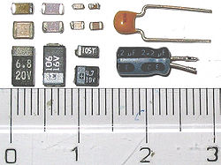

## Theory of operation

Main article: [Capacitance](http://en.wikipedia.org/wiki/Capacitance)

[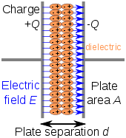](http://en.wikipedia.org/wiki/File:Capacitor_schematic_with_dielectric.svg)

[http://bits.wikimedia.org/skins-1.5/common/images/magnify-clip.png](http://en.wikipedia.org/wiki/File:Capacitor_schematic_with_dielectric.svg)

Charge separation in a parallel-plate capacitor causes an internal electric field. A dielectric (orange) reduces the field and increases the capacitance.

[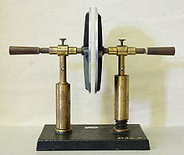](http://en.wikipedia.org/wiki/File:Plattenkondensator_hg.jpg)

[http://bits.wikimedia.org/skins-1.5/common/images/magnify-clip.png](http://en.wikipedia.org/wiki/File:Plattenkondensator_hg.jpg)

A simple demonstration of a parallel-plate capacitor

A capacitor consists of two [conductors](http://en.wikipedia.org/wiki/Conductor) separated by a non-conductive region.The non-conductive substance is called the [dielectric medium](http://en.wikipedia.org/wiki/Dielectric_medium), although this may also mean a [vacuum](http://en.wikipedia.org/wiki/Vacuum) or a [semiconductor](http://en.wikipedia.org/wiki/Semiconductor) [depletion region](http://en.wikipedia.org/wiki/Depletion_region) chemically identical to the conductors. A capacitor is assumed to be self-contained and isolated, with no net [electric charge](http://en.wikipedia.org/wiki/Electric_charge) and no influence from an external electric field. The conductors thus contain equal and opposite charges on their facing surfaces, and the dielectric contains an electric field. The capacitor is a reasonably general model for electric fields within electric circuits.

**RESISTOR**

Resistors are used to limit the value of current in a circuit. Resistors offer opposition to the flow of current. They are expressed in ohms for which the symbol is ‘Ω’. Resistors are broadly classified as

1. Fixed Resistors
2. Variable Resistors

**Fixed Resistors :**

The most common of low wattage, fixed type resistors is the molded-carbon composition resistor. The resistive material is of carbon clay composition. The leads are made of tinned copper. Resistors of this type are readily available in value ranging from few ohms to about 20MΩ, having a tolerance range of 5 to 20%. They are quite inexpensive. The relative size of all fixed resistors changes with the wattage rating.

Another variety of carbon composition resistors is the metalized type. It is made by deposition a homogeneous film of pure carbon over a glass, ceramic or other insulating core. This type of film-resistor is sometimes called the precision type, since it can be obtained with an accuracy of ±1%.

Lead Tinned Copper Material

Colour Coding Molded Carbon Clay Composition

Fixed Resistor

**A Wire Wound Resistor :**

It uses a length of resistance wire, such as nichrome. This wire is wounded on to a round hollow porcelain core. The ends of the winding are attached to these metal pieces inserted in the core. Tinned copper wire leads are attached to these metal pieces. This assembly is coated with an enamel coating powdered glass. This coating is very smooth and gives mechanical protection to winding. Commonly available wire wound resistors have resistance values ranging from 1Ω to 100KΩ, and wattage rating up to about 200W.

**Coding Of Resistor :**

Some resistors are large enough in size to have their resistance printed on the body. However there are some resistors that are too small in size to have numbers printed on them. Therefore, a system of colour coding is used to indicate their values. For fixed, moulded composition resistor four colour bands are printed on one end of the outer casing. The colour bands are always read left to right from the end that has the bands closest to it. The first and second band represents the first and second significant digits, of the resistance value. The third band is for the number of zeros that follow the second digit. In case the third band is gold or silver, it represents a multiplying factor of 0.1to 0.01. The fourth band represents the manufacture’s tolerance.

## 

RESISTOR COLOUR CHART

5 green

0 black

1 brown

2 red

3 orange

4 yellow

6 blue

7 purple

8 silver

9 white

5 green

0 black

1 brown

2 red

3 orange

4 yellow

6 blue

7 purple

8 silver

9 white

5 green

0 black

1 brown

2 red

3 orange

4 yellow

6 blue

7 purple

8 silver

9 white

0 black

1 brown

2 red

3 orange

4 yellow

6 blue

7 purple

8 silver

9 white

5 green

**For example**, if a resistor has a colour band sequence: yellow, violet, orange and gold

Then its range will be—

Yellow=4, violet=7, orange=10³, gold=±5% =47KΏ ±5% =2.35KΏ

**Most resistors have 4 bands:**

* The first band gives the first digit.
* The second band gives the second digit.
* The third band indicates the number of zeros.
* The fourth band is used to show the tolerance (precision) of the resistor.

resistor

This resistor has red (2), violet (7), yellow (4 zeros) and gold bands.   
So its value is 270000 ohm= 270 kohm.

The standard colour code cannot show values of less than 10ohm. To show these small values two special colours are used for the third band: gold, which means × 0.1 and silver which means × 0.01. The first and second bands represent the digits as normal.

**For example:**

red, violet, gold bands represent 27 × 0.1 = 2.7 ohm  
blue, green, silver bands represent 56 × 0.01 = 0.56 ohm

The fourth band of the colour code shows the tolerance of a resistor. Tolerance is the precision of the resistor and it is given as a percentage. For example a 390ohm resistor with a tolerance of ±10% will have a value within 10% of 390ohm, between 390 - 39 = 351ohm and 390 + 39 = 429ohm (39 is 10% of 390).

A special colour code is used for the fourth band tolerance:  
silver ±10%,   gold ±5%,   red ±2%,   brown ±1%.   
If no fourth band is shown the tolerance is ±20%.

**VARIABLE RESISTOR:**In electronic circuits, sometimes it becomes necessary to adjust the values of currents and voltages. For n example it is often desired to change the volume of sound, the brightness of a television picture etc. Such adjustments can be done by using variable resistors.

**Although the variable resistors are usually called rheostats in other applications, the smaller variable resistors commonly used in electronic circuits are called potentiometers.**

### Resistor shorthand:

Resistor values are often written on circuit diagrams using a code system which avoids using a decimal point because it is easy to miss the small dot. Instead the letters R, K and M are used in place of the decimal point. To read the code: replace the letter with a decimal point, then multiply the value by 1000 if the letter was K, or 1000000 if the letter was M. The letter R means multiply by 1.

For example:

560R means 560 ohm  
2K7  means 2.7 kohm = 2700 ohm  
39K  means 39 kohm   
1M0  means 1.0 Mohm = 1000 kohm

### Power Ratings of Resistors

|  |
| --- |
| Resistor 5W |
| Resistor 25W |
| High power resistors (5W top, 25W bottom)  Photographs © [Rapid Electronics](http://www.rapidelectronics.co.uk/) |

**Electrical energy is converted to heat when current flows through a resistor. Usually the effect is negligible, but if the resistance is low (or the voltage across the resistor high) a large current may pass making the resistor become noticeably warm. The resistor must be able to withstand the heating effect and resistors have power ratings to show this.**

Power ratings of resistors are rarely quoted in parts lists because for most circuits the standard power ratings of 0.25W or 0.5W are suitable. For the rare cases where a higher power is required it should be clearly specified in the parts list, these will be circuits using low value resistors (less than about 300ohm) or high voltages (more than 15V).

The power, P, developed in a resistor is given by:

|  |  |  |
| --- | --- | --- |
| P = I² × R or  P = V² / R | where: | P = power developed in the resistor in watts (W)  I  = current through the resistor in amps (A)  R = resistance of the resistor in ohms (ohm)  V = voltage across the resistor in volts (V) |

**Examples:**

* A 470ohm resistor with 10V across it, needs a power rating P = V²/R = 10²/470 = 0.21W.   
  In this case a standard 0.25W resistor would be suitable.
* A 27ohm resistor with 10V across it, needs a power rating P = V²/R = 10²/27 = 3.7W.   
  A high power resistor with a rating of 5W would be suitable.

**TRANSISTORS**

A transistor is an active device. It consists of two PN junctions formed by sandwiching either p-type or n-type semiconductor between a pair of opposite types.

There are two types of transistor:

1. n-p-n transistor
2. p-n-p transistor

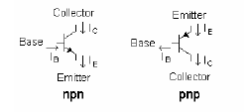

An n-p-n transistor is composed of two n-type semiconductors separated by a thin section of p-type. However a p-n-p type semiconductor is formed by two p-sections separated by a thin section of n-type.

Transistor has two pn junctions one junction is forward biased and other is reversed biased. The forward junction has a low resistance path whereas a reverse biased junction has a high resistance path.

The weak signal is introduced in the low resistance circuit and output is taken from the high resistance circuit. Therefore a transistor transfers a signal from a low resistance to high resistance.

Transistor has three sections of doped semiconductors. The section on one side is emitter and section on the opposite side is collector. The middle section is base.

**Emitter :** The section on one side that supplies charge carriers is called emitter. The emitter is always forward biased w.r.t. base.

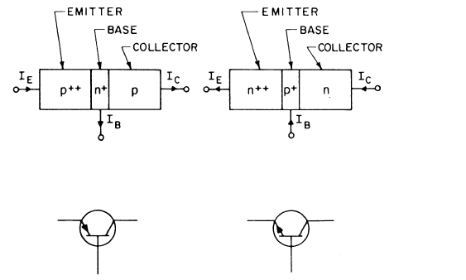

**Collector :** The section on the other side that collects the charge is called collector. The collector is always reversed biased.

**Base :** The middle section which forms two pn-junctions between the emitter and collector is called base.

A transistor raises the strength of a weak signal and thus acts as an amplifier. The weak signal is applied between emitter-base junction and output is taken across the load Rc connected in the collector circuit. The collector current flowing through a high load resistance Rc produces a large voltage across it. Thus a weak signal applied in the input appears in the amplified form in the collector circuit.

### Heat sink

**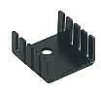**

Waste heat is produced in transistors due to the current flowing through them. Heat sinks are needed for power transistors because they pass large currents. If you find that a transistor is becoming too hot to touch it certainly needs a heat sink! The heat sink helps to dissipate (remove) the heat by transferring it to the surrounding air.

**CONNECTORS**

Connectors are basically used for interface between two. Here we use connectors for having interface between PCB and 8051 Microprocessor Kit.

There are two types of connectors they are male and female. The one, which is with pins inside, is female and other is male.

These connectors are having bus wires with them for connection.

For high frequency operation the average circumference of a coaxial cable must be limited to about one wavelength, in order to reduce multimodal propagation and eliminate erratic reflection coefficients, power losses, and signal distortion. The standardization of coaxial connectors during World War II was mandatory for microwave operation to maintain a low reflection coefficient or a low voltage standing wave ratio.

**Seven types of microwave coaxial connectors are as follows:**

1.APC-3.5

2.APC-7

3.BNC

4.SMA

5.SMC

6.TNC

7.Type N

**LED (LIGHT EMITTING DIODE)**

A junction diode, such as LED, can emit light or exhibit electro luminescence. Electro luminescence is obtained by injecting minority carriers into the region of a pn junction where radiative transition takes place. In radiative transition, there is a transition of electron from the conduction band to the valence band, which is made possibly by emission of a photon. Thus, emitted light comes from the hole electron recombination. What is required is that electrons should make a transition from higher energy level to lower energy level releasing photon of wavelength corresponding to the energy difference associated with this transition. In LED the supply of high-energy electron is provided by forward biasing the diode, thus injecting electrons into the n-region and holes into p-region.

The pn junction of LED is made from heavily doped material. On forward bias condition, majority carriers from both sides of the junction cross the potential barrier and enter the opposite side where they are then minority carrier and cause local minority carrier population to be larger than normal. This is termed as minority injection. These excess minority carrier diffuse away from the junction and recombine with majority carriers.

In LED, every injected electron takes part in a radiative recombination and hence gives rise to an emitted photon. Under reverse bias no carrier injection takes place and consequently no photon is emitted. For direct transition from conduction band to valence band the emission wavelength.

In practice, every electron does not take part in radiative recombination and hence, the efficiency of the device may be described in terms of the quantum efficiency which is defined as the rate of emission of photons divided by the rate of supply of electrons. The number of radiative recombination, that take place, is usually proportional to the carrier injection rate and hence to the total current flowing.

LED Materials:

One of the first materials used for LED is GaAs. This is a direct band gap material, i.e., it exhibits very high probability of direct transition of electron from conduction band to valence band. GaAs has E= 1.44 eV. This works in the infrared region.

GaP and GaAsP are higher band gap materials. Gallium phosphide is an indirect band gap semiconductor and has poor efficiency because band to band transitions are not normally observed.

Gallium Arsenide Phosphide is a tertiary alloy. This material has a special feature in that it changes from being direct band gap material.

Blue LEDs are of recent origin. The wide band gap materials such as GaN are one of the most promising LEDs for blue and green emission. Infrared LEDs are suitable for optical coupler applications.

ADVANTAGES OF LEDs:

1. Low operating voltage, current, and power consumption makes Leds compatible with electronic drive circuits. This also makes easier interfacing as compared to filament incandescent and electric discharge lamps.
2. The rugged, sealed packages developed for LEDs exhibit high resistance to mechanical shock and vibration and allow LEDs to be used in severe environmental conditions where other light sources would fail.
3. LED fabrication from solid-state materials ensures a longer operating lifetime, thereby improving overall reliability and lowering maintenance costs of the equipment in which they are installed.
4. The range of available LED colours-from red to orange, yellow, and green-provides the designer with added versatility.
5. LEDs have low inherent noise levels and also high immunity to externally generated noise.
6. Circuit response of LEDs is fast and stable, without surge currents or the prior “warm-up”, period required by filament light sources.
7. LEDs exhibit linearity of radiant power output with forward current over a wide range.

**LEDs have certain limitations such as:**

1. Temperature dependence of radiant output power and wave

length.

1. Sensitivity to damages by over voltage or over current.
2. Theoretical overall efficiency is not achieved except in special

cooled or pulsed conditions.

**DIODE**

**ACTIVE COMPONENT-**

Active component are those component for not any other component are used its operation. I used in this project only function diode, these component description are described as bellow.

# SEMICONDUCTOR DIODE-

A PN junctions is known as a semiconductor or crystal diode.A crystal diode has two terminal when it is connected in a circuit one thing is decide is weather a diode is forward or reversed biased. There is a easy rule to ascertain it. If the external CKT is trying to push the conventional current in the direction of error, the diode is forward biased. One the other hand if the conventional current is trying is trying to flow opposite the error head, the diode is reversed biased putting in simple words.

1. If arrowhead of diode symbol is positive W.R.T Bar of the symbol, the diode is forward biased.

2.The arrowhead of diode symbol is negative W.R.T bar , the diode is the reverse bias.

# CLOSING

* 1. **Conclusion**

Based on the results of analysis of all data obtained by testing the smart home with the Internet of Things based NodeMCU ESP6288 module, the following conclusions can be drawn:

1. Smart Home with Internet of Things (IoT) based NodeMCU ESP8266 Module can be designed with various components hardware and software support so that it can be arranged into a smart home system that is controlled with the Blynk android application according to what is intended.
2. The Smart Home with this Internet of Things (IoT) based NodeMCU ESP8266 Module can be implemented to control some of the home electronics performance including lighting controls, fan control, temperature monitoring, early warning systems and etc.

# Suggestions

In the design and manufacture of this final project there are still deficiencies that need to be corrected in order to perfect this final project, including:

1. Optimizing the power control consumption of the NodeMCU ESP8266 module to be further developed in wireless-based technology application, considering the current technology prioritizes low cost but efficient.
2. The development of an internet-based smart home system of things needs to be tested on other electronic devices in everyday life.

# REFERENCES

1. Arduino Temperature Sensor Using LM35. Groups of Electronics Hobbyist, Roboticist. We Developed Electronics Project Tutorials Make Open for Everyone.
2. BOHORA, Bharat; MAHARJAN, Sunil; SHRESTHA, Bibek Raj. IoT Based Smart Home Using Blynk Framework. Zerone Scholar, [S.l.], v. 1, n. 1, p. 26-30, dec. 2016. ISSN 2542- 2774. google scholar.
3. DC-DC Step Down Converter Power Supply Provides Regulated 5VDC Output with Range Input of 10-32VDC, Model GTD21088L-1505-T2.
4. Home Automation Using Internet of Thing 2016 IEEE 7th Annual Ubiquitous Computing, Electronics & Mobile Communication Conference (UEMCON) Published: 2016. Google Scholar.
5. Internet of Things in Home Automation and Energy Efficient Smart Home Technologies Simon G. M. Koo Department of Computer Engineering, Santa Clara University, CA 95053, USA
6. Low Cost Implementation of Smart Home Automation Ravi Kishore Kodali Department of Electronics and Communication Engineering National Institute of Technology, Warangal , 506004 India
7. [Mobile based home automation using Internet of Things (IoT)](https://ieeexplore.ieee.org/document/7475301/) 2015 International Conference on Control, Instrumentation, Communication and Computational Technologies (ICCICCT) Published: 2015
8. NodeMCU Features and Pinout. A Brief Tutorial on the Introduction to NodeMCU V3.
9. Yoyosteven in Circuits Microcontrollers. NODEMCU 1.0 (ESP8266) CONTROLLED RELAY USING BLYNK (OVER THE WEB).
10. 5V 4-Channel Relay Interface Board, Standard Interface that can be Controlled Directly by Microcontroller.
11. 15-17 March 2018 U. Venkanna IoT Based Smart Home Automation System Using Sensor Node. Google Scholar.